Global search
Public 360° is setup to index metadata from all entities in Public 360° as well as the content of files.

To search
Simply type in your search term in the Global search field (1) and press Enter or click the magnifying glass.
The result is presented as a list consisting of all hits (2), whether it’s files (including file content), cases, documents, estates, projects or other entities. The result set is ranked according to the best hits.
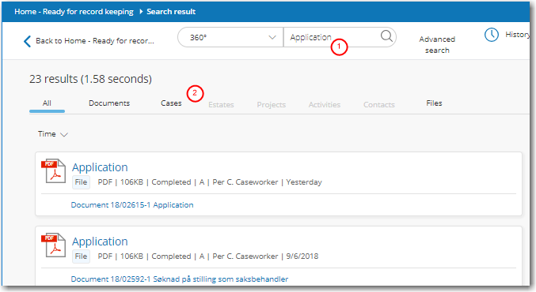

Filter your search result
You can filter your search result to find exactly what you want. Filtering your search results does not change any of your search settings.
Using element filters
Below each element tab, you find additional filters that you can apply to your search. The filters are customized for each element type. In the example below, we have selected the Documents element and opened the Categoryfilter.
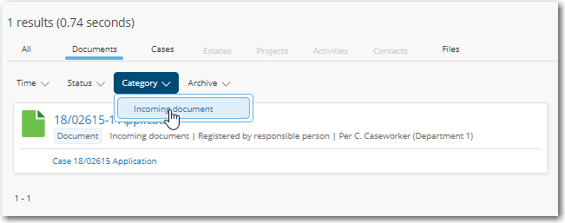
By clicking Clear, you can at any time clear the filter and return to the original search result list.
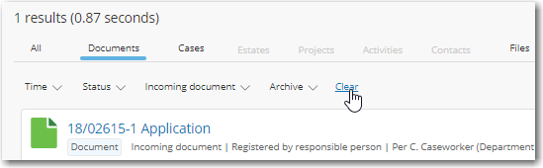

Advanced search
The Advanced search facility gives you a number of search fields to use individually or in combination.
Unlike Global Search, Advanced search consists of a number of search fields linked to corresponding fields in the database. Advanced search produces search results if the values entered in the search fields match those stored in the database.
NOTE. This help topic is not updated
1. Open Advanced search and then the element type you want to search for.
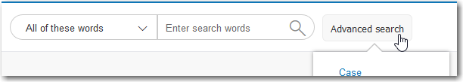
2. The easiest way to create a search is to start with an existing search favourite.
3. Add the required search criteria and click Search.

