WISEflow for participants
Contents
Logging in 2
Types of FLOWs 3
School exam 4
Installing the Lockdown browser 4
On the Day of the Exam 5
FLOWmulti: Interactive school exam 6
Annotation and overview tools 6
Appendix manager 9
Resolving technical issues during school exams 11
Losing internet connection 11
Technical issues 12
Direct messages 12
Unauthorized gesture 12
Submitting your paper 13
Practical assignment 14

Logging in
Use Google Chrome or Firefox, go to europe.wiseflow.net and log in using FEIDE (student number + password).
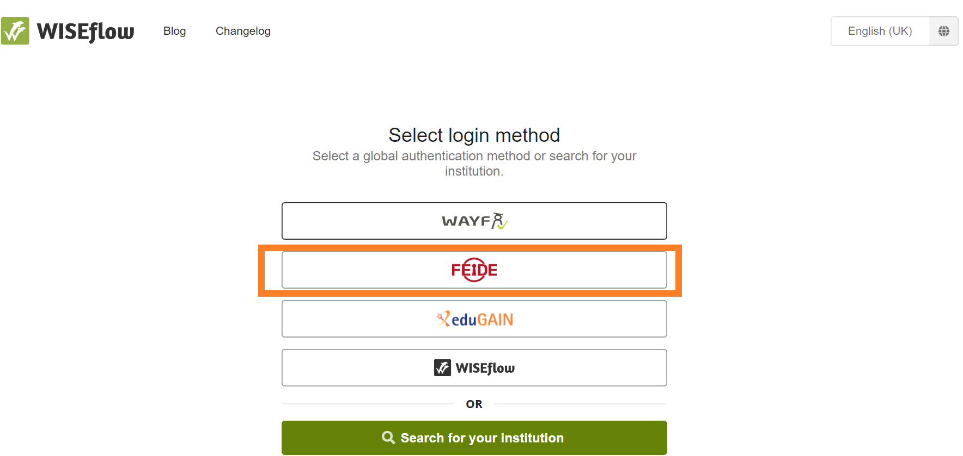
NB! Make sure that you have chosen NHH as your affiliation. If you forgot your FEIDE-password, you can reset it.
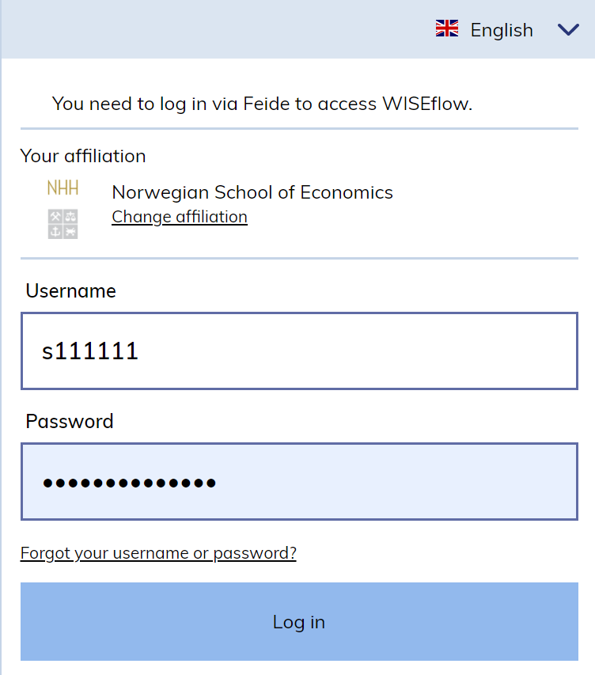
- Under Participation you will find an overview over your current exam flows
- Those that are open for participation are marked with green
- Older flows are available in the Participant Archive
- You can practice in DEMO flows
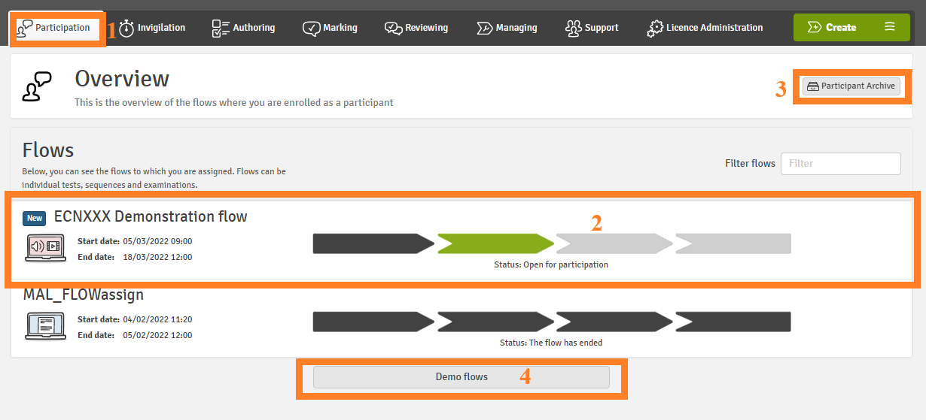

Types of FLOWs

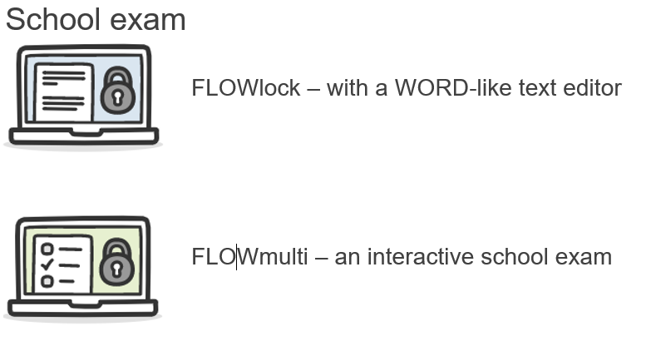

School exam
Most school exams are conducted either in FLOWlock or in FLOWmulti that use the lockdown browser to restrict your computer from accessing unauthorized material during the test period.

Installing the Lockdown browser
- Log in with FEIDE
- Click on your name in the upper right corner and select Edit profile.
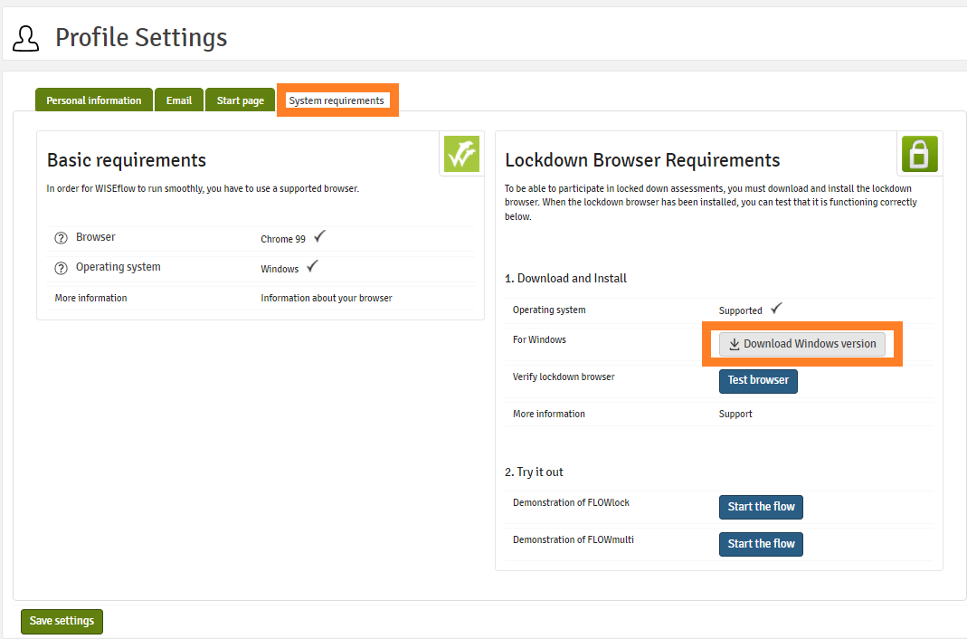

- Go to System requirements.
- Make sure that Browser and Operating system under basic requirements are ticked off.

Non-Compatible Devices or Operating Systems
The installation of the lockdown browser is not supported on Linux, Windows 10S and Chromebooks.

- Download the latest version of the Lockdown browser.
After installing, click Test browser to verify. You may also try out some features of FLOWlock or FLOWmulti by clicking Start the flow.
NB! The old FLOWlock browser will stop working after the new release, make sure your browser is up to date before the exam!

Error message: the current version of the FLOWlock browser is not installed
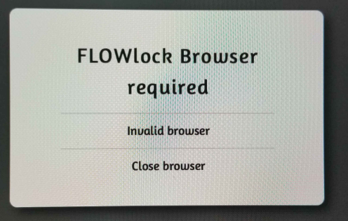

On the Day of the Exam
- Choose the exam flow from the list
- In the flow, click Start the flow to launch the FLOWlock browser
- When the lockdown browser is launched, you will be taken to a page that shows a countdown to the beginning of the exam.
- You must launch the lockdown browser before the beginning of the exam in order to gain access to the flow
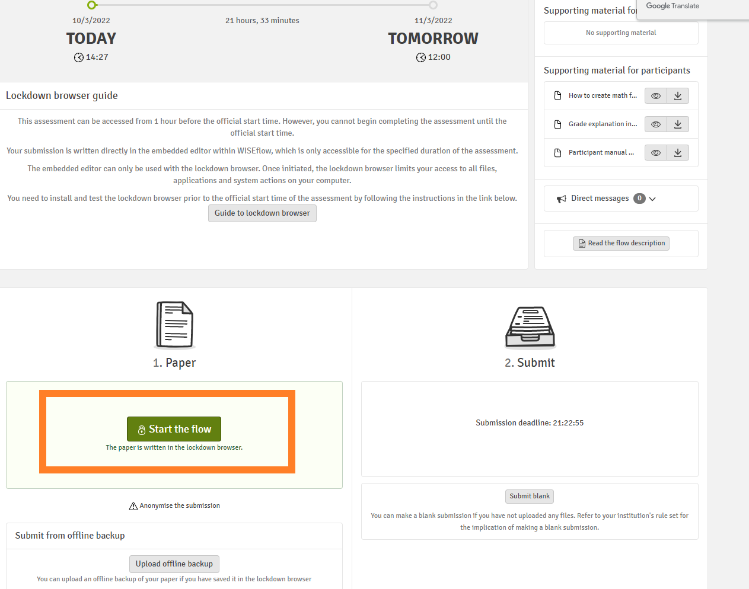

FLOWmulti: Interactive exam
You can practice in FLOWmulti – advanced demoflow
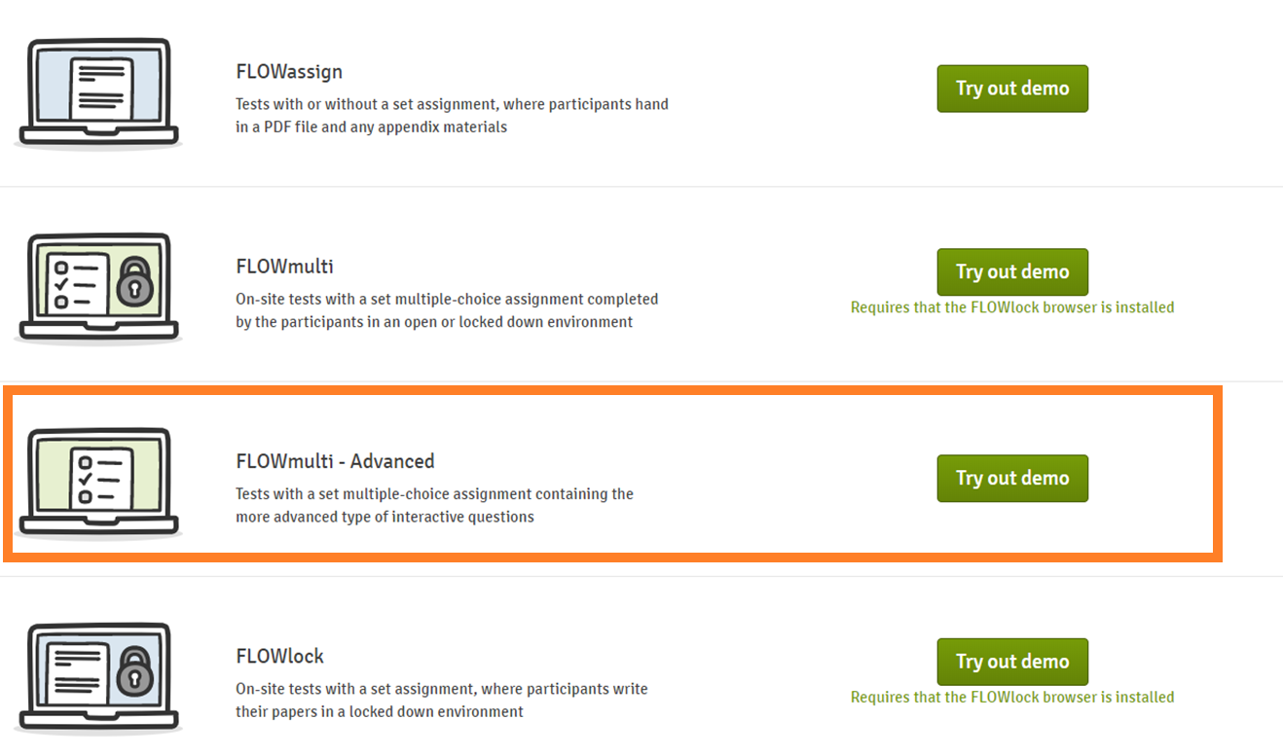
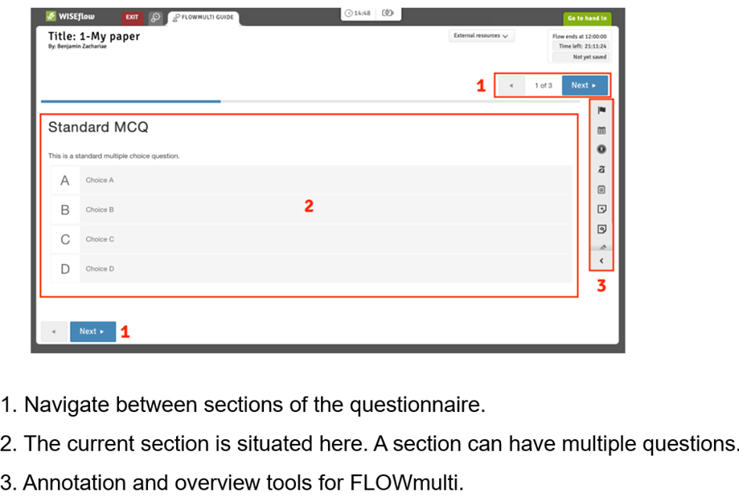

Annotation and overview tools
Flag section: Mark the current section. This allows easy backtracking if needed, as you can filter flagged sections in the overview.
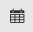
Overview: Go to the overview page.
The overview has all sections listed. You can filter for flagged and unattempted sections to the right.
Accessibility: Change color scheme, font size, and see zoom commands for the browser.
Exclude answers: Click here to enable the exclusion of answers. When the tool is enabled (blue) click answers to make them un-clickable. With the tool enabled, click the excluded answer again to unlock it.
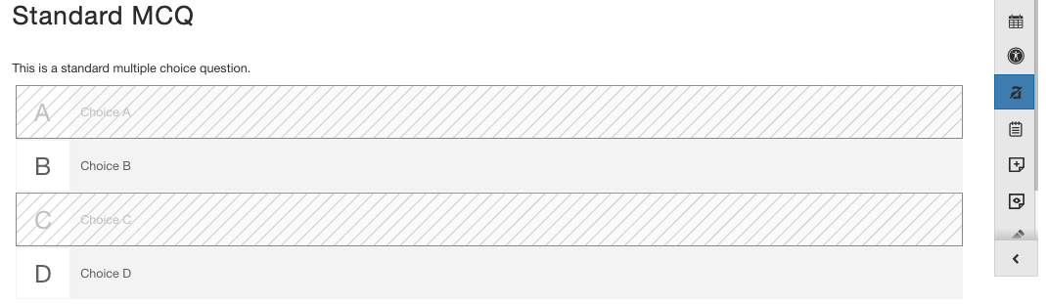
Notepad: Add personal notes to the exam. These are not visible to others but the participant. This notepad is concurrent on for all sections.
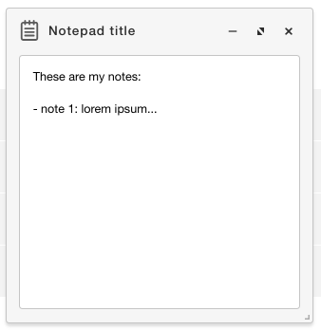
Click the line to minimize the notepad and the arrows to make it full screen.
Add sticky notes: Add yellow notes to the current section.
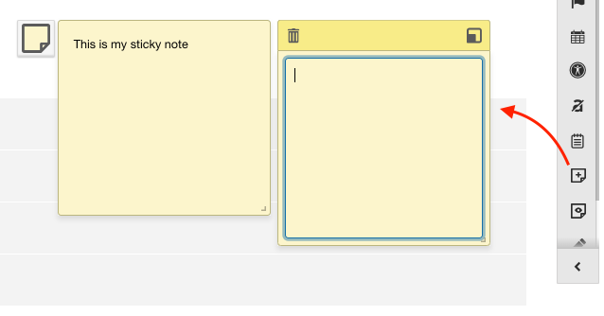
These notes are placed specifically in the section and are not visible to anyone but the participant. Click the top right button of the note to minimize the note.
View/hide sticky notes: Click here to hide or view sticky notes

Enter/exit drawing mode: Click here to start drawing mode. Here you can draw on the current section. This drawing is only visible to the participant.
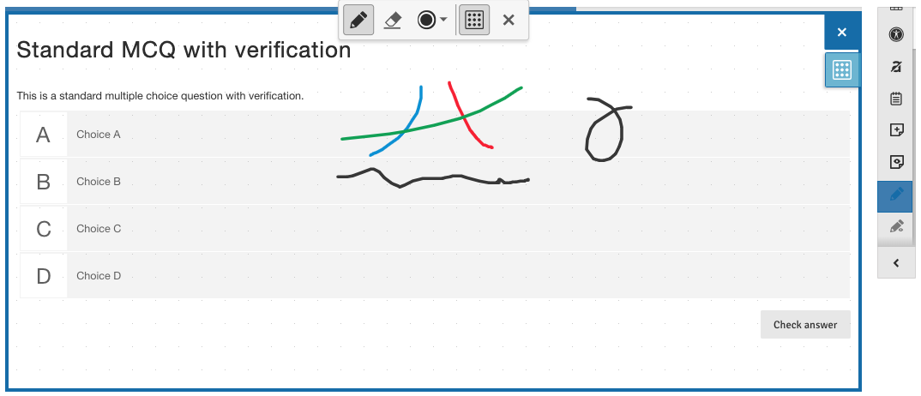
View/hide drawings: Hide or view drawings on the section.

Appendix manager
For specific question types you can add appendices to the section. Click the "Manage appendices" to open the Appendix manager in a new tab.
The appendix manager shows you which section is open.
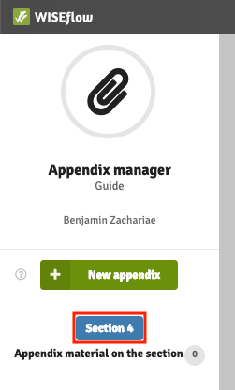
You can preview appendices for the section in the dropdown to the right of the manage appendices button.
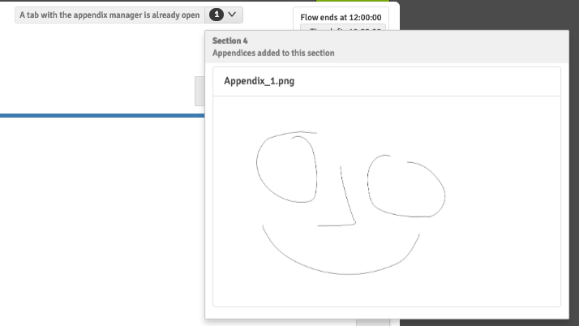
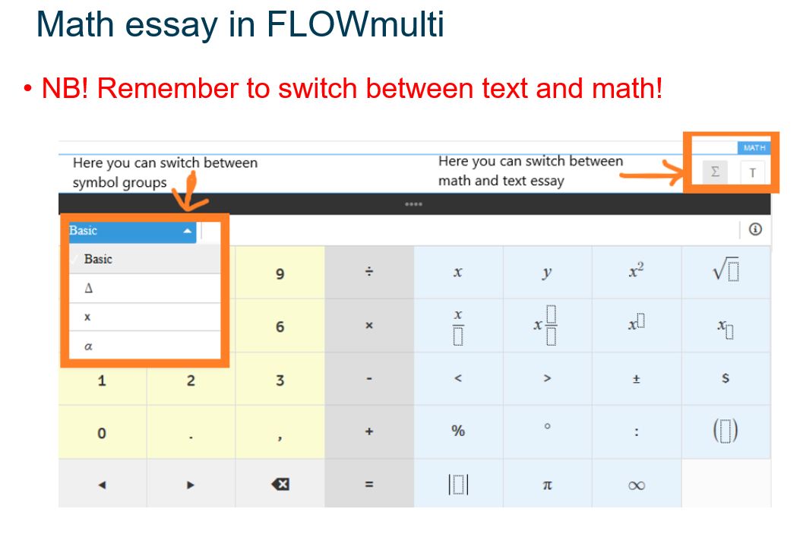

Resolving technical issues during school exams

Losing internet connection
Do not be worried if you get this message during the exam: press Ok and continue working
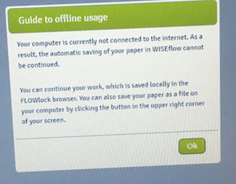

You can monitor your connection status on the top of the browser: if you are not connected to the internet for over 5 minutes, please, contact a technical invigilator.
NB! Do not refresh the browser while offline.
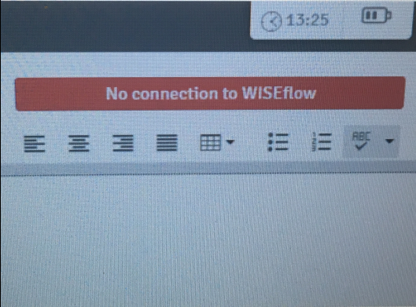

Technical issues
If you are online, but are experiencing other issues, for example, the extra time is not showing, refresh the browser. If the problem persists, take contact with a technical invigilator
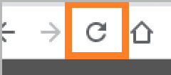

Direct messages
- Important information and instructions
- Pop up automatically
- Can be found on the top of the page
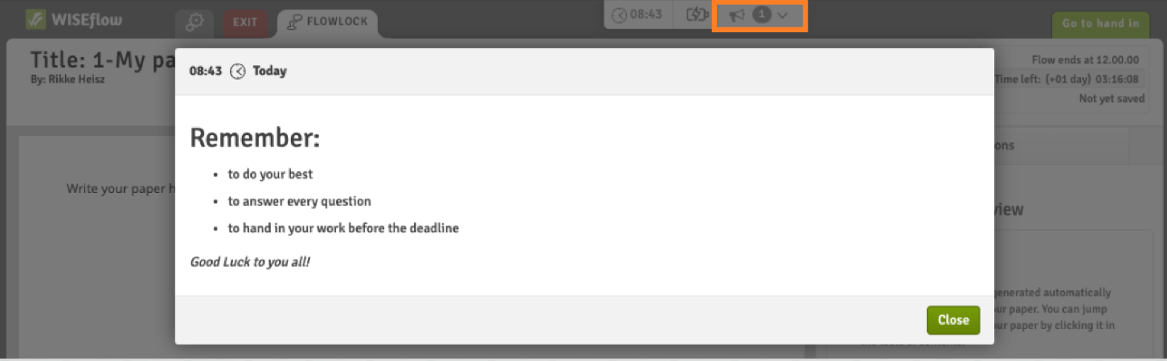

Unauthorized gesture
If you perform a keyboard combination or touchpad gesture that is not allowed inside the lockdown browser, you will receive a warning message that an illegal keyboard or touchpad gesture has been detected by the system. You will have to acknowledge the message but can continue working inside the lockdown browser.
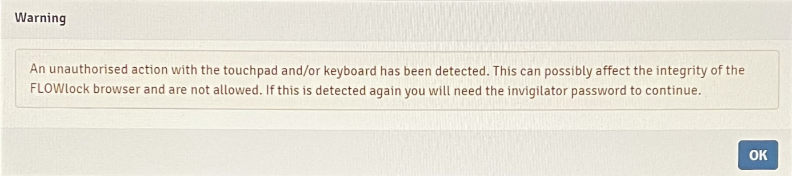
If an unauthorized keyboard combination or touchpad gesture is detected for a second time, you will receive another warning message and will have to include the invigilator password to continue working.
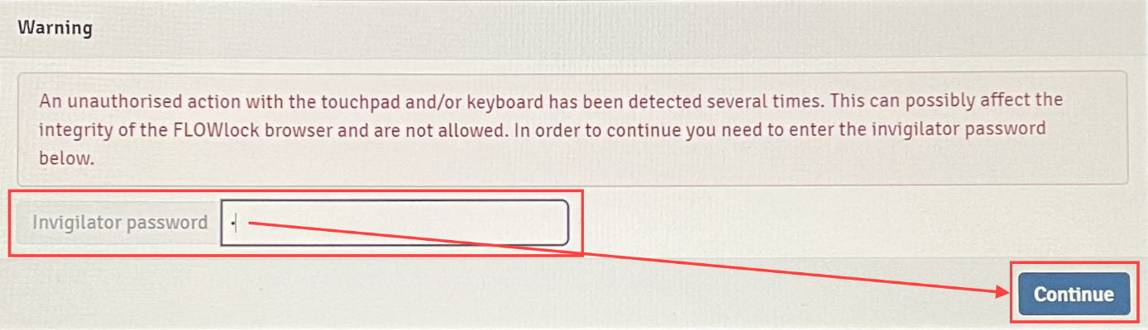
Troubleshooting guide: https://wiseflow.zendesk.com/hc/en-gb/articles/4406002375314

Submitting your paper
You can hand in or exit without handing in (an invigilator will have to enter the password)
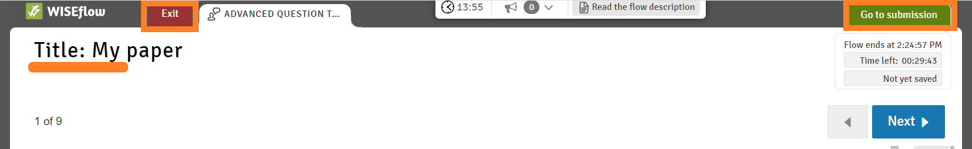
When you have submitted your exam within the lockdown browser, you will be brought back to the flow page where you will see a confirmation with a timestamp of your submission. You can also request a receipt as proof.

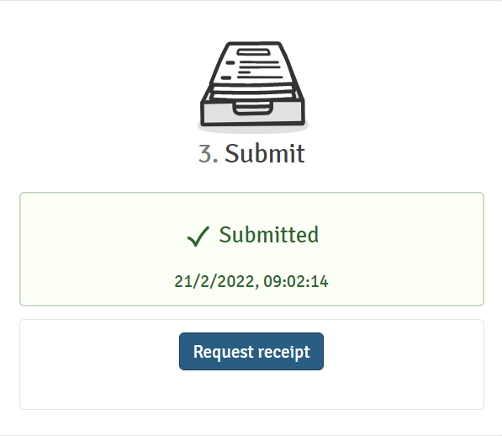

Practical assignment

- Download and install the FLOWlock browser
- Open the demo FLOWmulti – Advanced
  - Go to page 8 (math essay). Practice to switch between math and text, write some text and math formulas

