WISEflow for participants
Contents
Logging in 2
Types of FLOWs 3
School exam 4
Installing the Lockdown browser 4
On the Day of the Exam 5
FLOWlock exams 6
Zooming in and out 6
Inserting symbols 6
Toolbar: Formatting your answer 7
Permitted internet resources 8
Navigation 8
Assignment viewer 11
Create appendices 16
Insert appendices into the paper 19
Delete Appendices 19
Resolving technical issues during school exams 20
Losing internet connection 20
Technical issues 21
Direct messages 21
Unauthorized gesture 22
Submitting your paper 22
Practical assignment 23

Logging in
- Use Google Chrome or Firefox to go to europe.wiseflow.net
- Click on Go to WISEflow

- log in using FEIDE (student number + password).
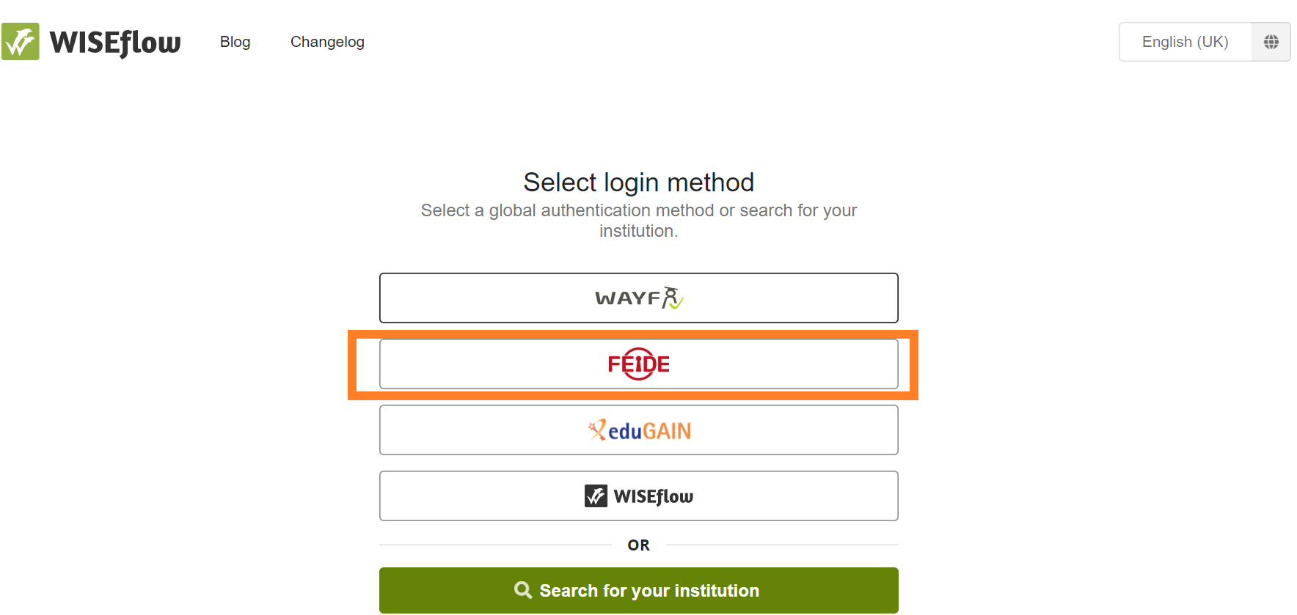
NB! Make sure that you have chosen NHH as your affiliation. If you forgot your FEIDE-password, you can reset it.
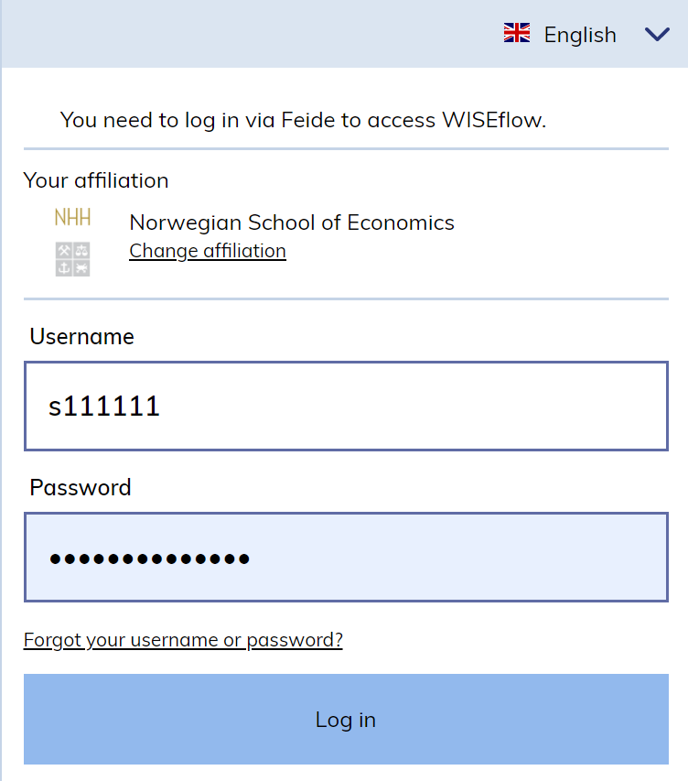
- Under Participation you will find an overview over your current exam flows
- Those that are open for participation are marked with green
- Older flows are available in the Participant Archive
- You can practice in DEMO flows
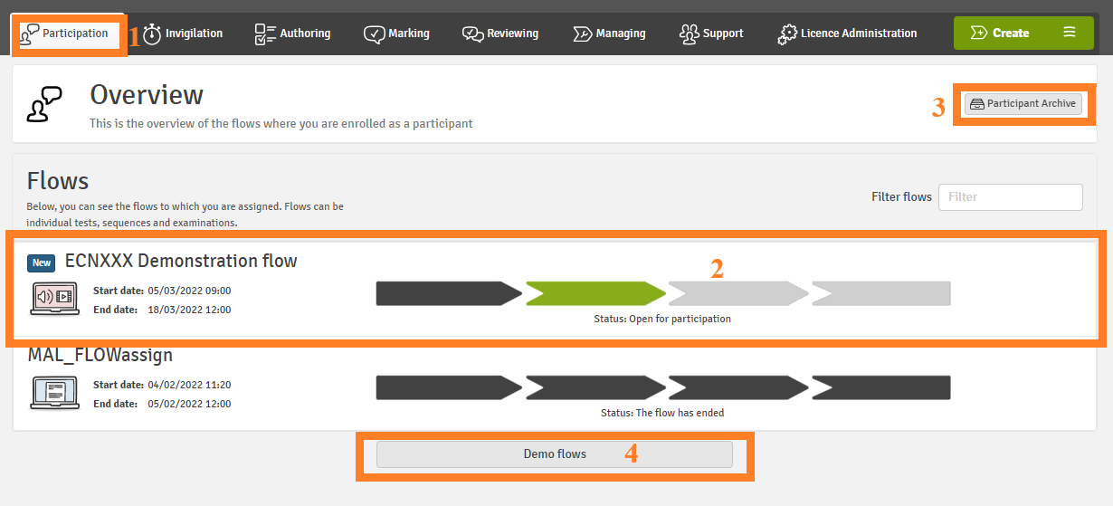

Types of FLOWs

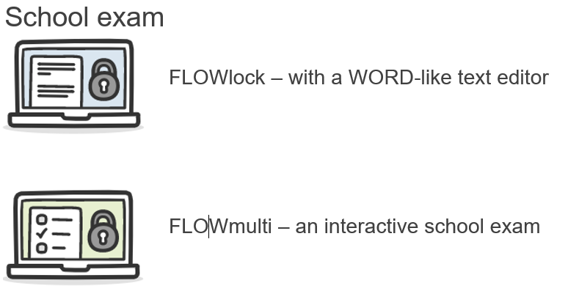

School exam
Most school exams are conducted either in FLOWlock or in FLOWmulti that use the lockdown browser to restrict your computer from accessing unauthorized material during the test period.

Installing the Lockdown browser
- Log in with FEIDE
- Click on your name in the upper right corner and select Edit profile.
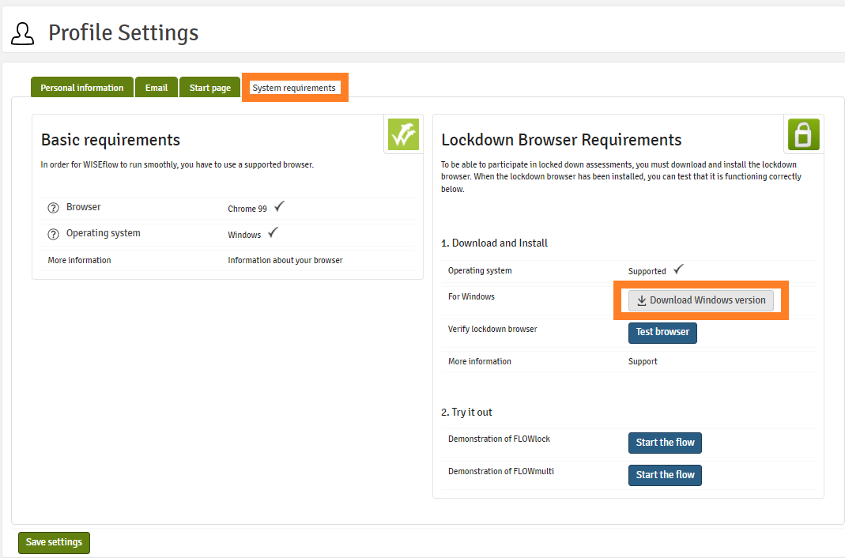
- Go to System requirements.
- Make sure that Browser and Operating system under basic requirements are ticked off.

Non-Compatible Devices or Operating Systems
The installation of the lockdown browser is not supported on Linux, Windows 10S and Chromebooks.

- Download the latest version of the Lockdown browser.
After installing, click Test browser to verify. You may also try out some features of FLOWlock or FLOWmulti by clicking Start the flow.
NB! The old FLOWlock browser will stop working after the new release, make sure your browser is up to date before the exam!

Error message: the current version of the FLOWlock browser is not installed
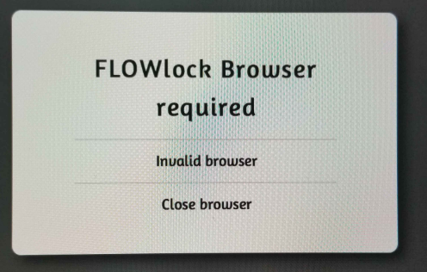

On the Day of the Exam
- Choose the exam flow from the list
- In the flow, click Start the flow to launch the FLOWlock browser
- When the lockdown browser is launched, you will be taken to a page that shows a countdown to the beginning of the exam.
- You must launch the lockdown browser before the beginning of the exam in order to gain access to the flow
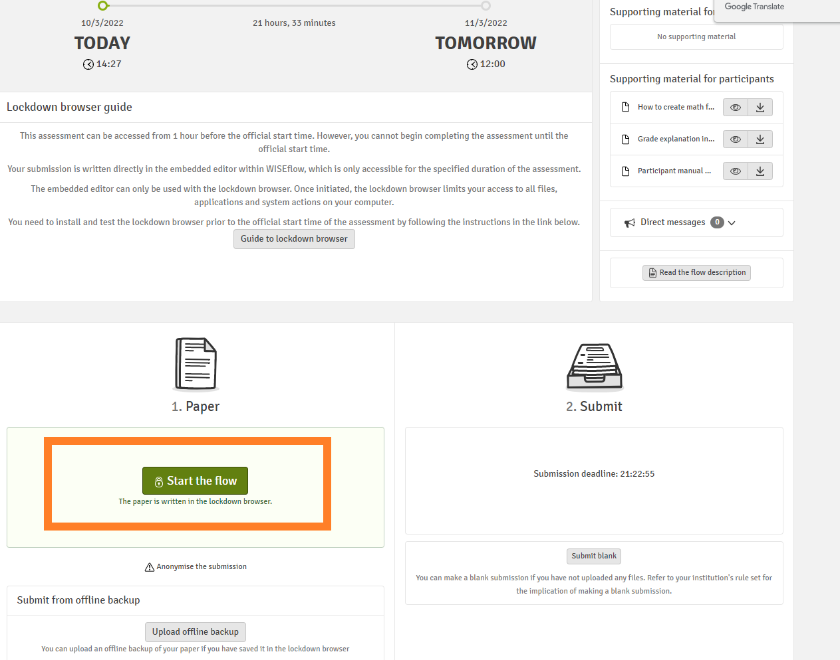

FLOWlock exams
FLOWlock has a Word-like text editor
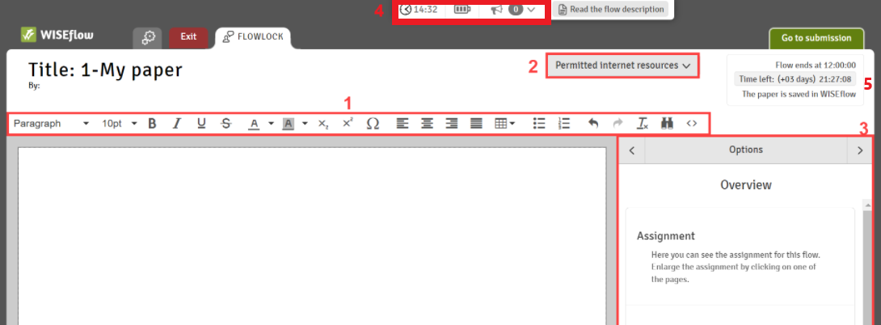

Zooming in and out
Click on the small info circle in the top menu. This will open the settings window where you have the option to set a zoom level and apply it.
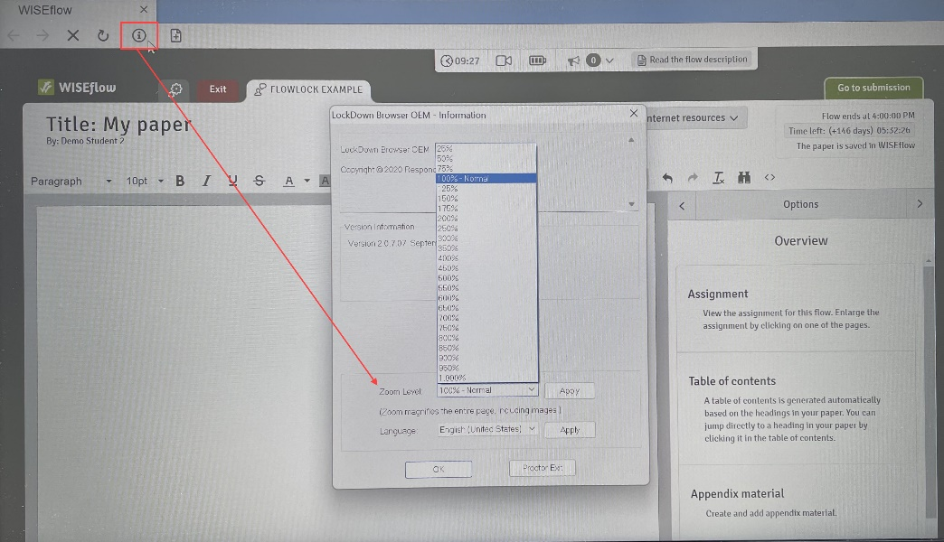

Inserting symbols
Insert symbols that are not available on your keyboard by clicking on the document icon with a plus sign on the upper left-hand side.
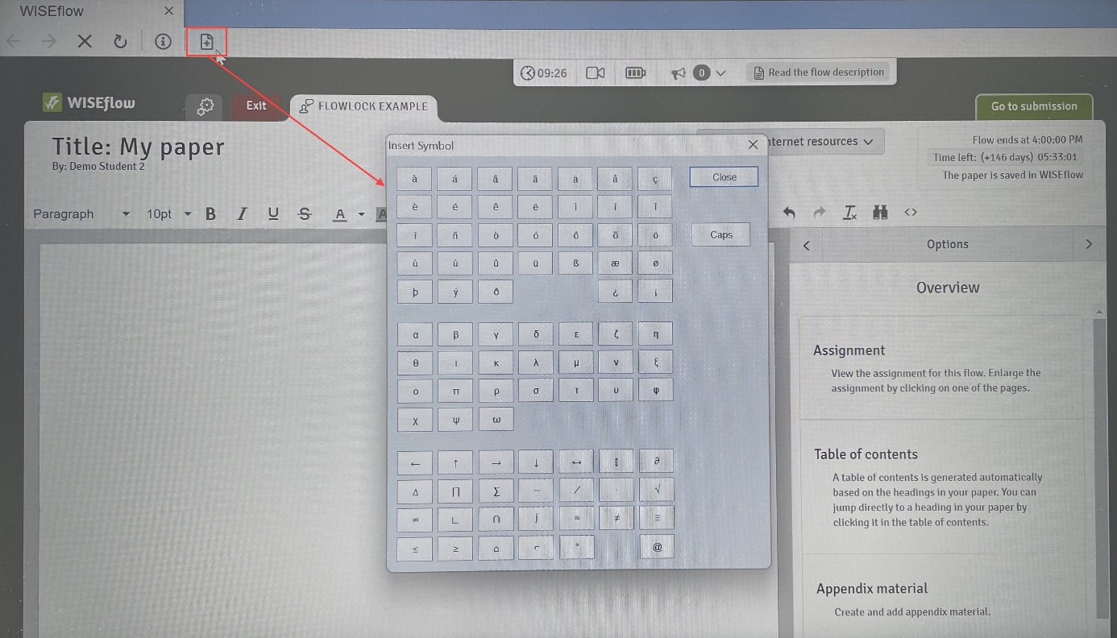

Toolbar: Formatting your answer
In the toolbar (1) you can design your text as you would with any normal text editor (e.g., Word). Design possibilities include: select text block types (e.g. Headline or Paragraph), insert tables, make lists, and disable/enable spellcheck and choose language

NB! Your answer paper will be converted to a PDF-file, there can be margin width discrepancies, thus some words can be moved to a new line.
If the alignment is important (e.g., accounting), create a table!

To create a table, use a table tool from a toolbar:
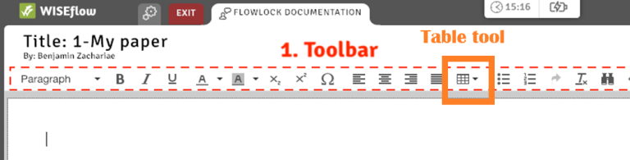

Permitted internet resources
If the external resources were provided, you will find them here
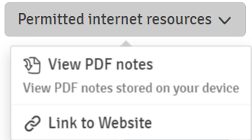

Navigation
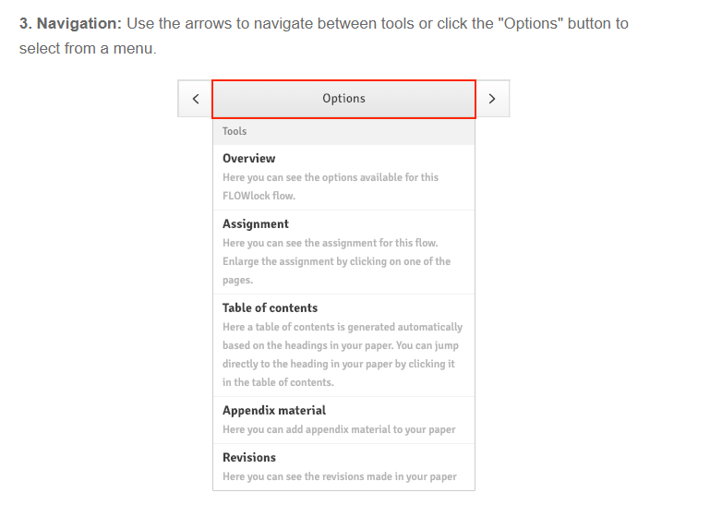
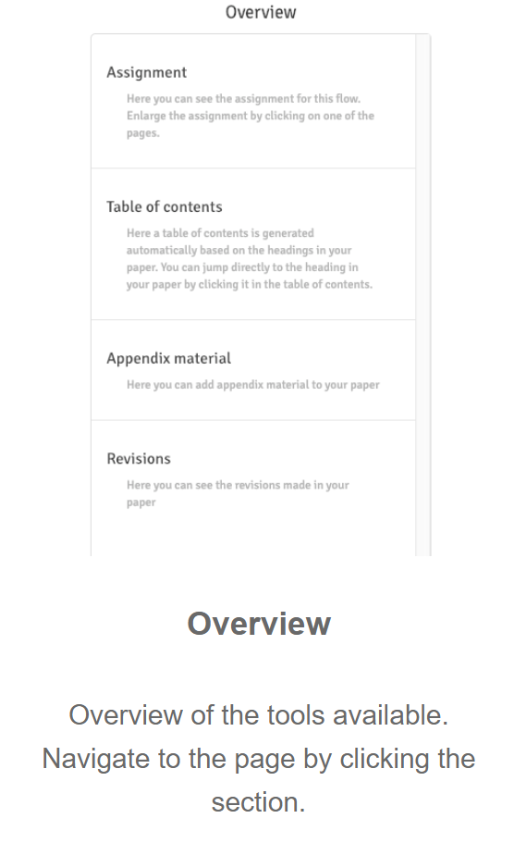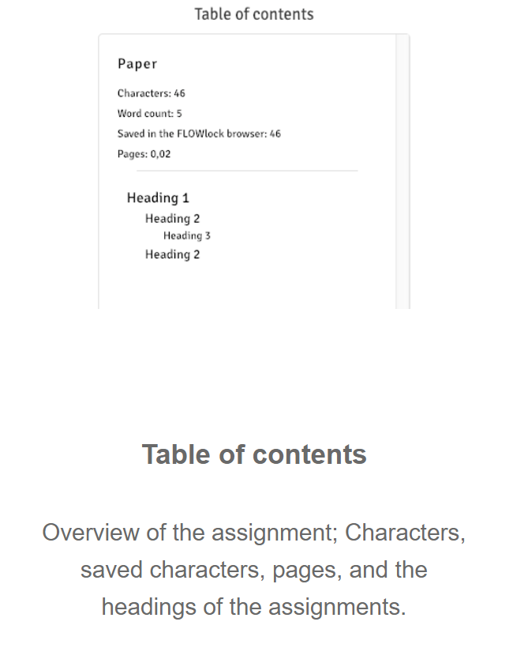

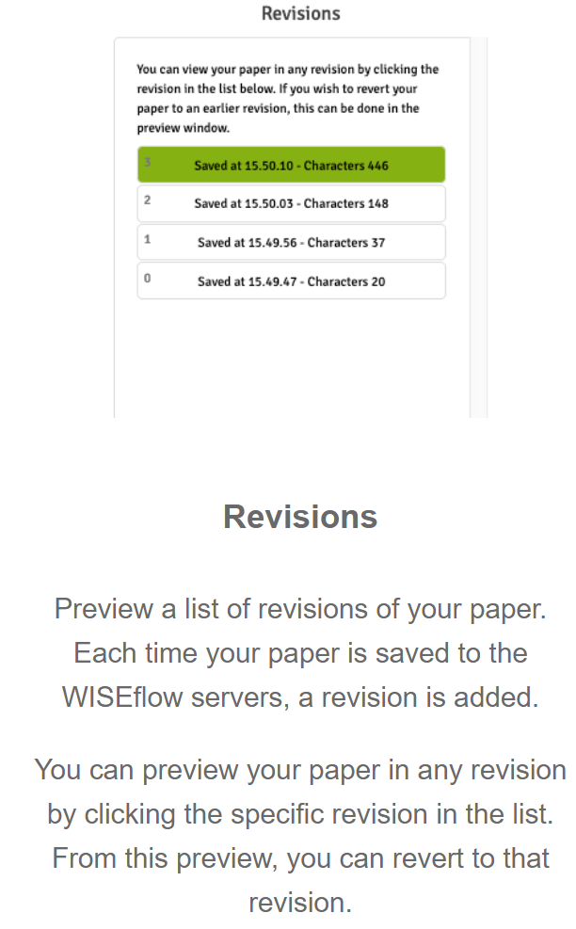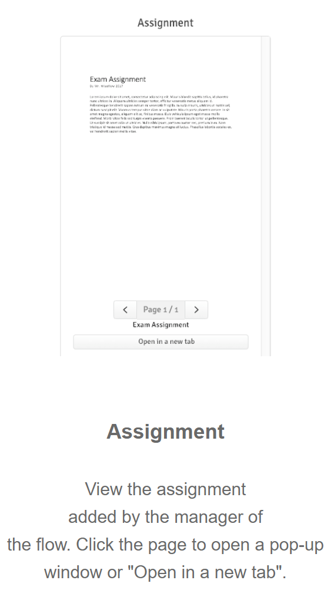
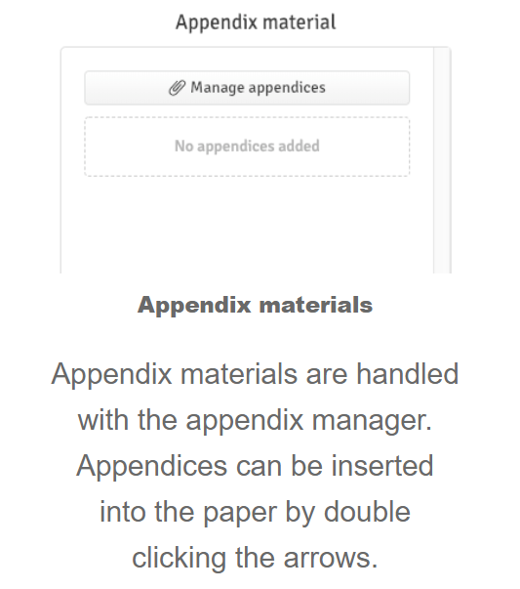

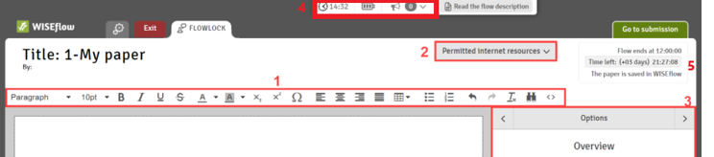
. The panel on top shows current time, battery status, and gives you possibility to review direct messages sent by administrators.
5. You can hide the countdown clock by clicking on the timer
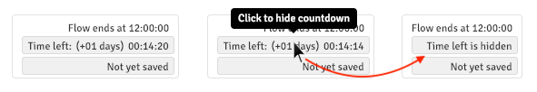

Assignment viewer
When a FLOWlock exam is written in the lockdown environment, you can annotate or comment on the assignment in the assignment viewer. Opening the assignment in a new tab will provide you with a full PDF reader which allows for annotations on the assignment.
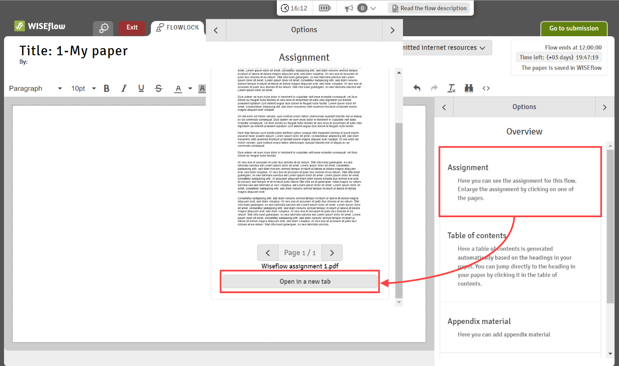
NB! The assignment viewer cannot be used on iPads as assignments cannot be opened in a new tab there.
Any annotations and comments that have been made will be saved even if the internet connection is lost during the exam as these are saved on your computer. It will not be possible to access annotated assignments if you have to switch to a different computer / laptop during the exam.
Annotations will not be shown when viewing the assignment in the main lockdown view where you can compose your answer.
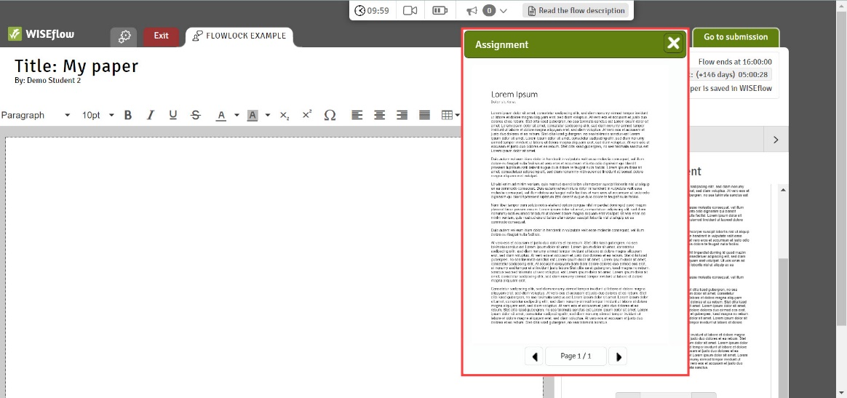
You have various options to annotate the assignment, make comments in the assignment viewer or, when in view mode, copy text from the assignment and paste it into the text editor in the lockdown browser:
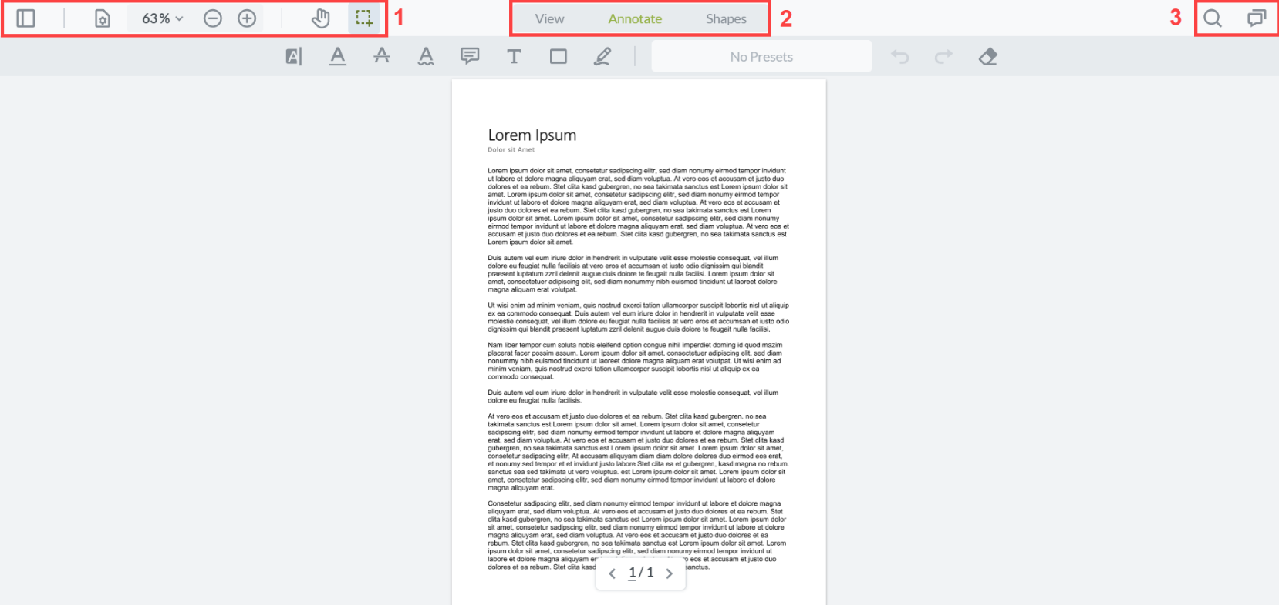
1. General Navigation
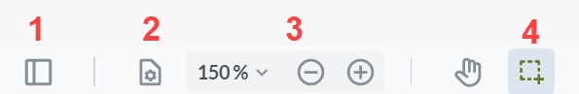
- If an assignment consists of several pages, a panel view lets you quickly jump to other pages.
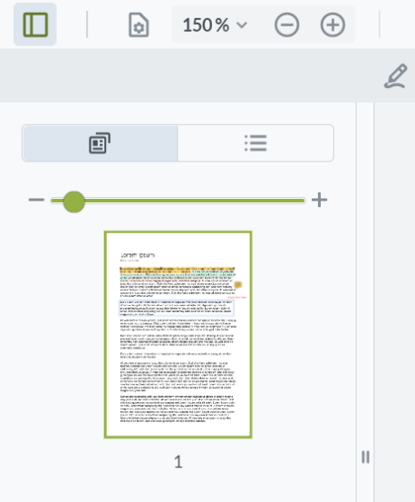
- Change the page transition, orientation, or layout.
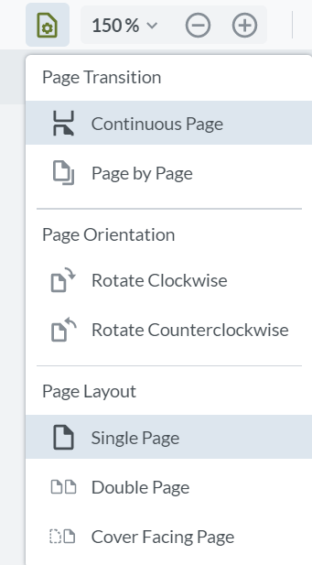
- Zoom in or out in the assignment.
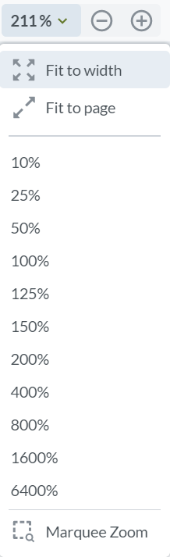
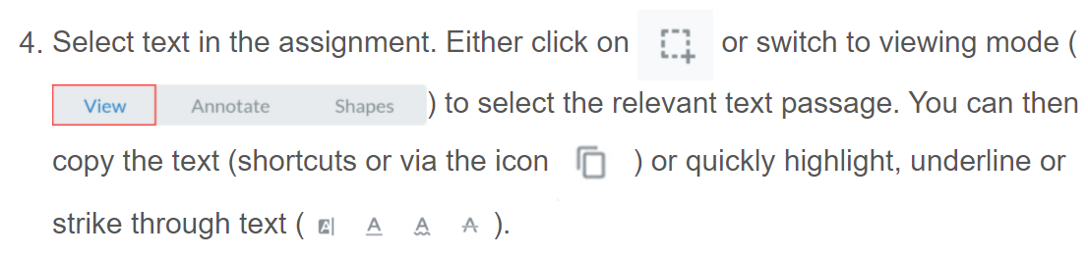
2. Annotate and comment
You can annotate the assignment with the following features:
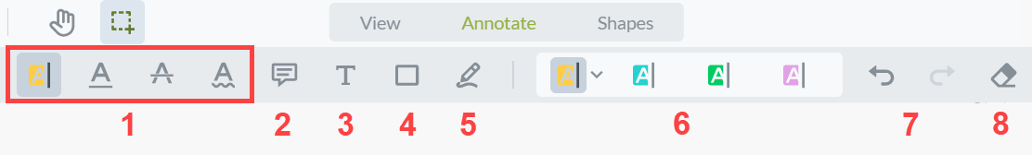
- Highlight, underline, strike through or underline text.
- Include a note on the assignment.
- Include text on the assignment.
- Include rectangle.
- Include free hand highlights.
- View presets or change color of annotations.
- Undo or redo changes.
- Erase annotations or comments.
You can also include shapes on your assignment.
When you include an annotation or shape on your assignment, you then have the option to include a comment, change the style or delete the annotation again ().

3. Search for words and through comments
You can either search for keywords in the assignment or search through comments that you have already made . When searching for keywords, you can decide whether the search should be case sensitive or applied to a whole word. You can adjust the size of the search results by dragging the border to the left or right. If the results should be hidden from view, simply click on . Delete your input in the search field if you would like to remove the highlighted text.
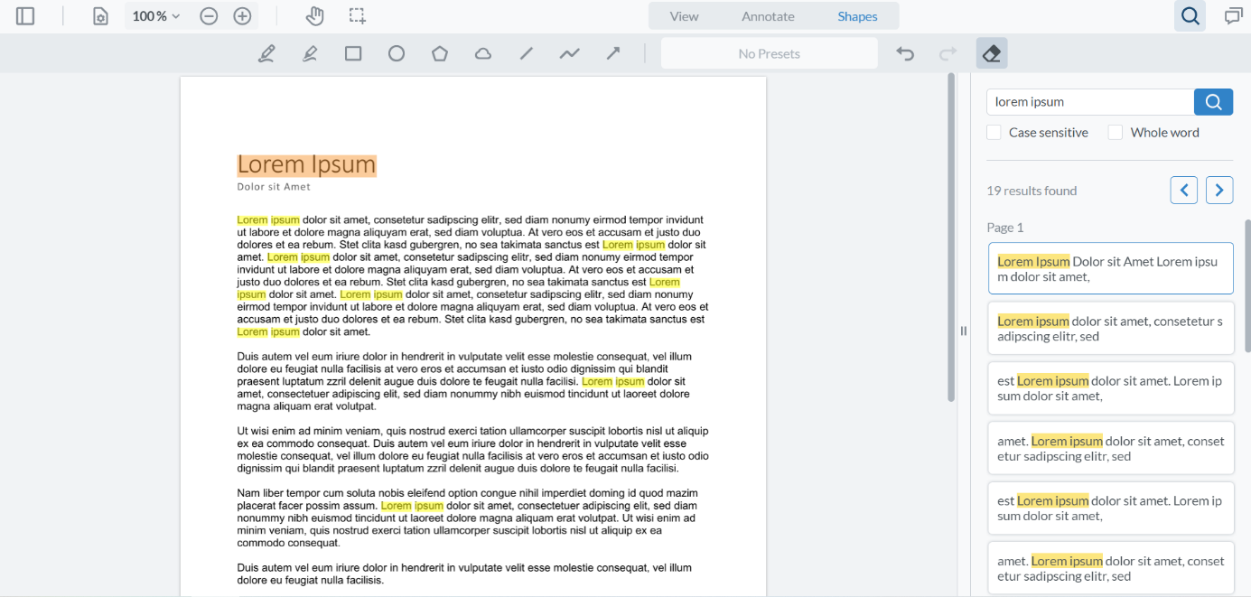
When searching through comments, you can also filter your comments by types (highlighted, underlined text, shapes, etc.) or by the colours of your annotations. You can also sort your comments by position, time, status, author, type, or colour.
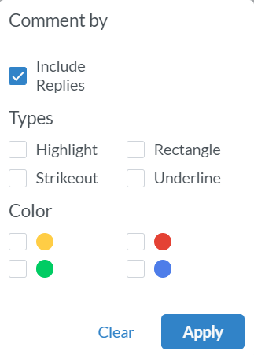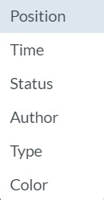
To get a better overview of all your comments, you can also drag the border to the left or, to make the view less prominent, to the right. Click on if the search results should be hidden from view entirely. Please note that any filters or sorting you have previously set up will still be visible when you reopen the comment section.
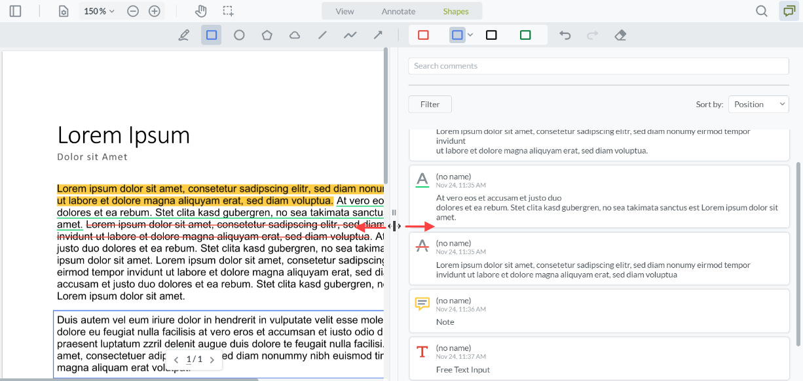

Create appendices
The appendix manager helps you create and manage your appendices. Once uploaded, the appendices are automatically submitted at the same time when you hand in your main paper. They can be viewed via the navigation pane on the right-hand side of the screen.
Depending on the set up of the flow, the tools available to you may vary.
In FLOWlock you will access the appendix manager in the right side of the paper.
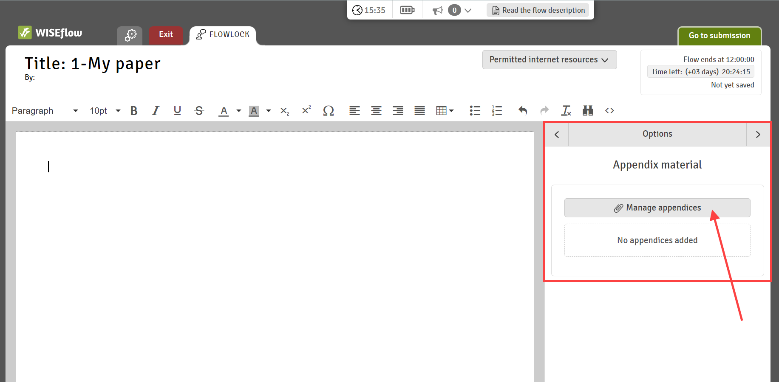

When you open the appendix manager you can add a new appendix by clicking +New appendix. You can now choose between the available tools on the flow.
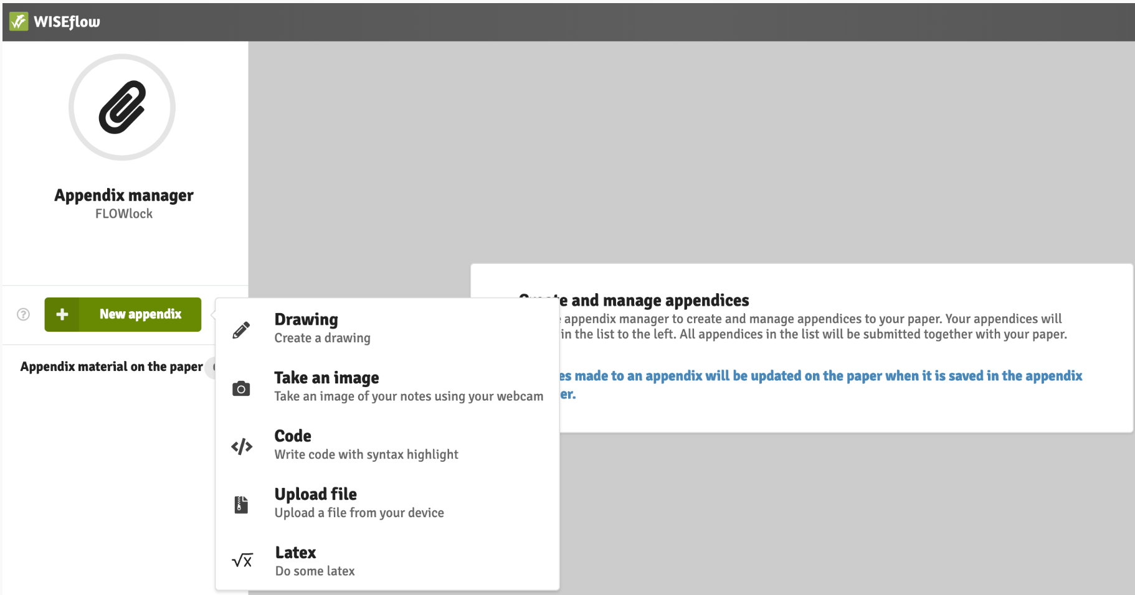

Drawing tool
You can draw your own image using the drawing tool. In the new drawing tool, you have access to more advanced tools.
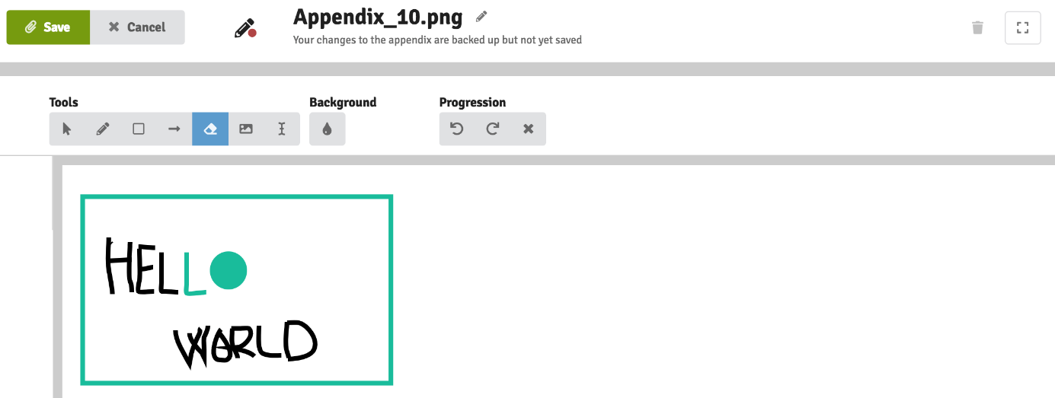

Code editor
In the code editor you can write code in different languages with syntax highlight.
Code language: Javascript, Go, Typescript, CSS, C++, C#, Python, XML, Markdown, Java, Ruby, Sass, JSON, HTML, SQL and PHP.
In addition to syntax highlighting the following also includes a structure error checker: HTML, CSS, Javascript, JSON and XML
Editor themes: Xcode, Monokai, Terminal, Github, Solarized Dark and Solarized Light.
Font size: 12, 14, 16, 18, 20, 24.
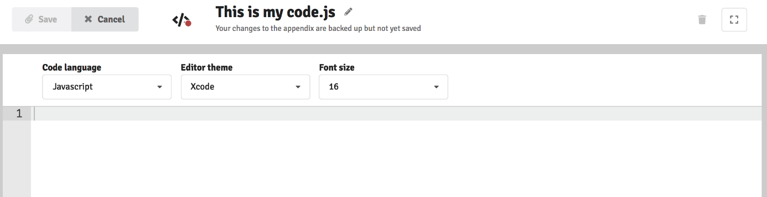
Note: In FLOWlock you can copy the code to your clipboard and paste it into your paper. Afterwards you highlight the passage of code in the paper and choose Code block under Paragraph. This will mark the code with grey and format the code correctly.

Webcam: Take an image
The appendix manager can take pictures with your (external) webcam and as an example can be used to take images of handwritten notes. Make sure that any external camera is plugged in before the start of the lockdown browser.
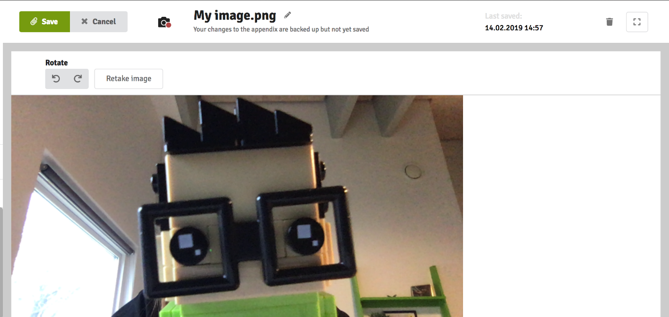

Formula editor
In the formula editor you can write LaTex formulas.
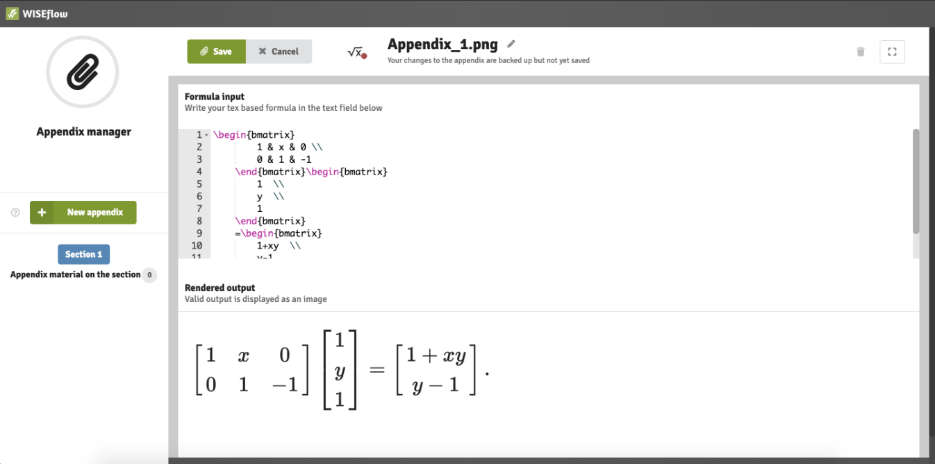
List of available commands: https://wiseflow.zendesk.com/hc/en-gb/articles/4406096809746

Upload a File
Using this feature will allow you to upload a file from your device. The file will be added to the paper as an appendix.
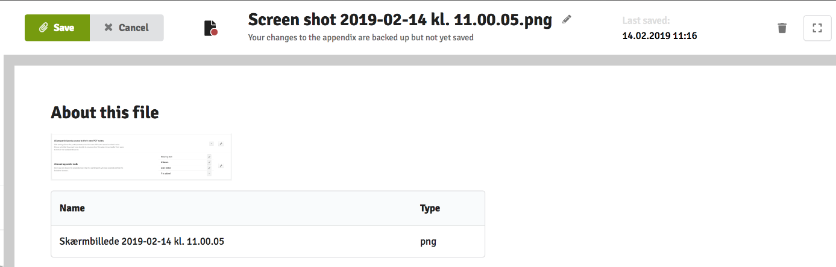

Insert appendices into the paper
Appendix material with a double arrow button can be inserted into the paper. Press the button twice to insert the material at the location of the cursor in the text.
Note: This is only a feature available on FLOWlock.
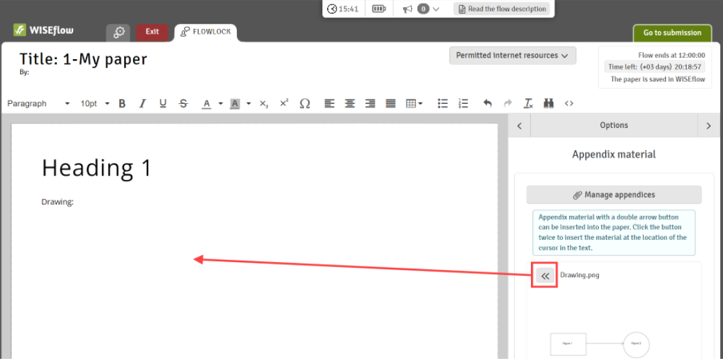

Delete Appendices
When you have created and saved an appendix that should no longer be included in your paper, you can delete it directly in the appendix manager. Choose the appendix material that should be deleted, click on the recycle bin in the upper right-hand corner and confirm that you would like to delete this appendix.
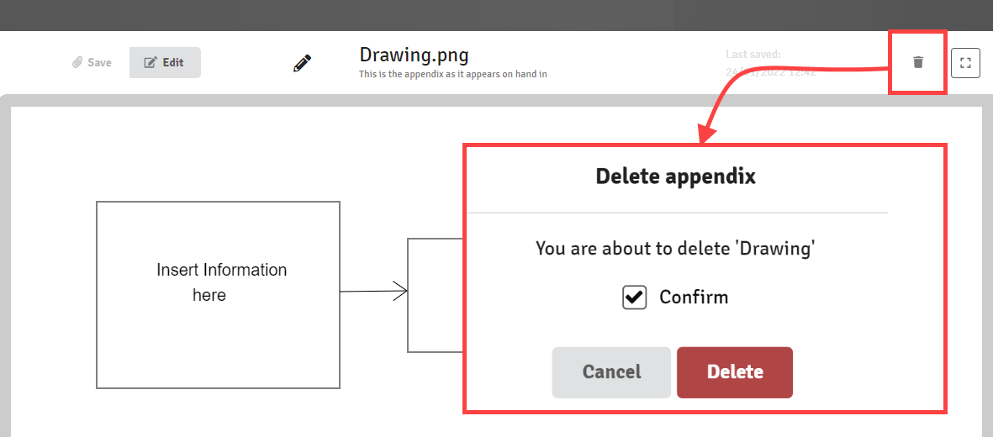

Resolving technical issues during school exams

Losing internet connection
Do not be worried if you get this message during the exam: press Ok and continue working
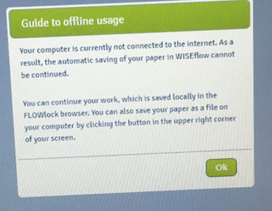

You can monitor your connection status on the top of the browser: if you are not connected to the internet for over 5 minutes, please, contact a technical invigilator.
NB! Do not refresh the browser while offline.
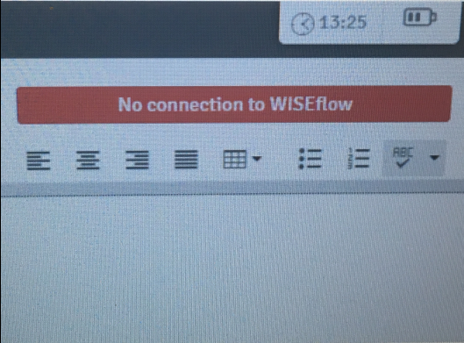

Technical issues
If you are online, but are experiencing other issues, for example, the extra time is not showing, refresh the browser. If the problem persists, take contact with a technical invigilator
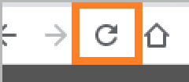

Direct messages
- Important information and instructions
- Pop up automatically
- Can be found on the top of the page
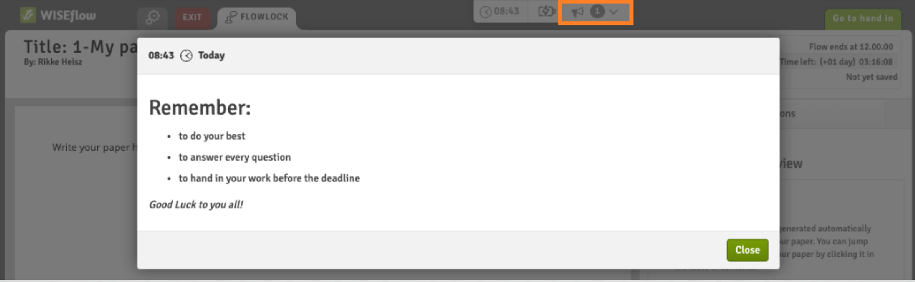

Unauthorized gesture
If you perform a keyboard combination or touchpad gesture that is not allowed inside the lockdown browser, you will receive a warning message that an illegal keyboard or touchpad gesture has been detected by the system. You will have to acknowledge the message but can continue working inside the lockdown browser.
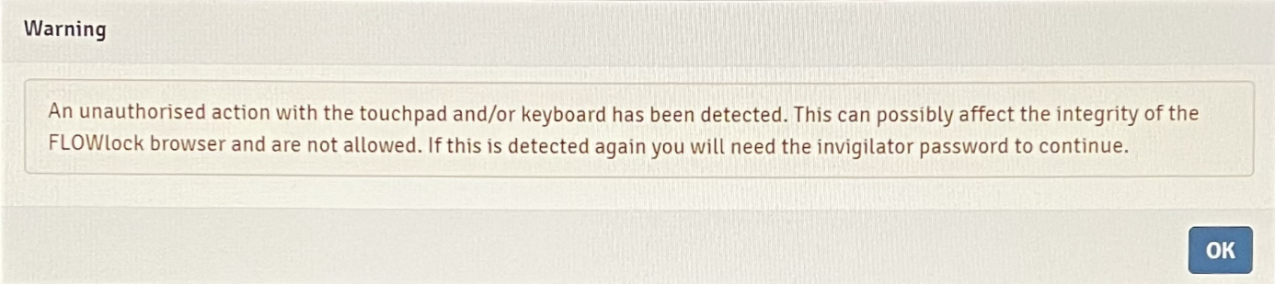
If an unauthorized keyboard combination or touchpad gesture is detected for a second time, you will receive another warning message and will have to include the invigilator password to continue working.
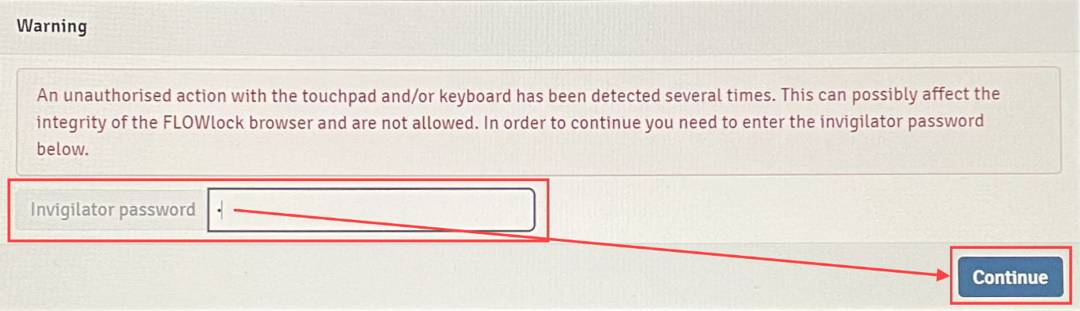
Troubleshooting guide: https://wiseflow.zendesk.com/hc/en-gb/articles/4406002375314

Submitting your paper
You can hand in or exit without handing in (an invigilator will have to enter the password)
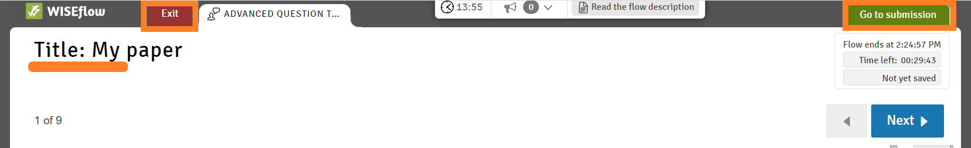
When you have submitted your exam within the lockdown browser, you will be brought back to the flow page where you will see a confirmation with a timestamp of your submission. You can also request a receipt as proof.

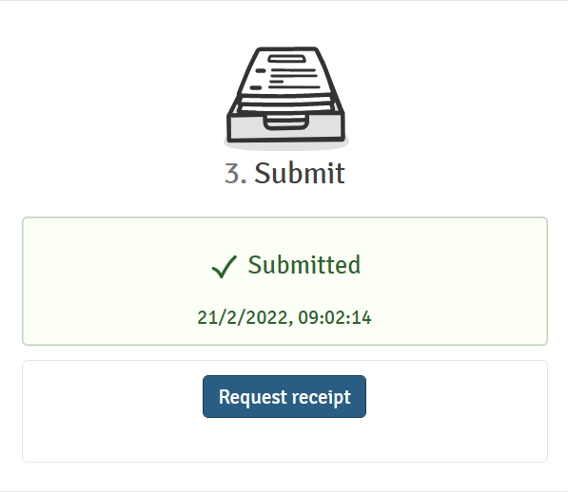

Practical assignment

- Download and install the FLOWlock browser
- Open the demo FLOWlock
  - Create a table
  - Take a picture with your webcam and insert it in the paper

