The development of children’s preferences for equality and equity across 13 individualistic and collectivist cultures

Elizabeth Huppert¹, Jason M. Cowell^{1,2}, Yawei Cheng³, Carlos Contreras⁴, Natalia Gomez-Sicard⁵, Luz Maria Gonzalez-Gaeda⁶, David Huepe⁷, Agustin Ibanez^{6,7}, Kang Lee⁸, Randa Mahasneh⁹, Susan Malcolm-Smith¹⁰, Natalia Salas¹¹, Bilge Selcuk¹², Bertil Tungodden¹³, Alina Wong¹⁴, Xinyue Zhou¹⁴, and Jean Decety^{1CA}

1. Department of Psychology, The University of Chicago, USA
2. Department of Psychology, The University of Wisconsin Green Bay, USA
3. Institute of Neuroscience, National Yang-Ming University, Taipei, Taiwan
4. Department of Sociology, Universidad Autonoma Metropolitana-Iztapalapa, Mexico
5. Research Division Neurosketch SAA, Bogota, Colombia
6. INECO Foundation, Favaloro University and National Scientific and Technical Research Council, Buenos Aires, Argentina.
7. Center for Social and Cognitive Neuroscience, School of Psychology, Universidad Adolfo Ibáñez, Santiago, Chile
8. Erick Jackman Institute of Child Study, University of Toronto, Canada
9. College of Education, Qatar University, Qatar
10. Department of Psychology, University of Cape Town, South Africa
11. Faculty of Education at the Universidad Autónoma de Chile, Chile
12. Department of Psychology, Koc University, Turkey
13. Department of Economics, Norwegian School of Economics, Norway
14. Dirección de Extensión Universitaria, Universidad de La Habana, Cuba
15. School of Management, Zhejiang University, China

Corresponding author:

Dr. Jean Decety
The Child Neurosuite
University of Chicago
5848 S. University Avenue
Chicago, IL 60637, USA
Email: decety@uchicago.edu

Abstract: A concern for fairness is a fundamental and universal element of morality. To examine the extent to which cultural norms are integrated into fairness cognitions and influence social preferences regarding equality and equity, a large sample of children (N 2,163) aged 4-11 were tested in 13 diverse countries. Children participated in three versions of a third-party, contextualized distributive justice game between two hypothetical recipients differing in terms of wealth, merit, and empathy. Social decision-making in these games revealed universal age-related shifts from equality-based to equity-based distribution strategies across cultures. However, differences in levels of individualism and collectivism between the 13 countries predicted the age and extent to which children favor equity in each condition. Children from the most individualistic cultures endorsed equitable distributions to a greater degree than children from more collectivist cultures when recipients differed in regards to wealth and merit. However, in an empathy context where recipients differed in injury, children from the most collectivist cultures exhibited greater preferences to distribute resource equitably compared to children from more individualistic cultures. Children from the more individualistic cultures also favored equitable distributions at an earlier age than children from more collectivist cultures overall. These results demonstrate aspects of both cross-cultural similarity and divergence in the development of fairness preferences.

Keywords: Collectivism/Individualism, Fairness, Resource allocation, Equity, Equality, Social decision-making, Cross-cultural development, Morality

Research Highlights
1. The influence of culture on fairness cognitions was examined with a large sample of children (N > 2,000) aged 4-11 from 13 diverse countries.
2. Children played three distributive justice games in which the recipients differed in terms of wealth, merit, or empathy to measure concerns for equality and equity.
3. Across countries, children exhibited similar age-related trajectories in allocation preferences.
4. Levels of individualism versus collectivism impacted the age at which children favored equitable distributions over equal distributions, and the magnitude of equity preferences.

Introduction
Fairness is an essential component of large-scale, coordinated cooperation (Dawes, Fowler, Johnson, McElreath, & Smirnov, 2007). A concern with fairness may have evolved as an effective strategy in mutualistic situations, since a fair division of resources can help promote cooperation and sustain social systems (Baumard, André, & Sperber, 2013; Decety & Yoder, 2017). Fair resource distributions tend to increase group functioning, and consequently, benefit individuals within the group (Deutsch, 1975). Consistent with this perspective, people react negatively to violations of unfairness and consider evidence of past fairness to be a sign of a good social partner (Shaw, DeScioli, & Olson, 2012). Even children are motivated to behave fairly; however, conceptions of fairness change with age in childhood (McAuliffe, Blake, Steinbeis, & Warneken, 2017).

A desire for equality is present at a young age. Children expect fairness from others (Dunfield, Kuhlmeier, & Murphy, 2013), and reflect this expectation in their own behaviors by 15 months of age (Schmidt & Sommerville, 2011). By age 3, children endorse norms of equality in third-party resource allocation tasks where they do not stand to gain in resources (Smith, Blake, & Harris, 2013). When asked to distribute resources between two anonymous recipients in a distributive justice game, young children prefer equal distributions when no other information about the recipients is available (Malti et al., 2016). Even when recipients are described as contributing differently to a joint task, young children prefer equality in distributions, in which both partners receive the same amount of resources, compared to equity in distributions, in which recipients are given more resources when they contribute more effort (Baumard, Mascaro, & Chevallier, 2012). In situations where children cannot distribute equally, some will even throw away extra resources to avoid uneven distributions (Shaw & Olson, 2012). Equality appears to be synonymous with fairness in early childhood.

As children age, they integrate social norms into more nuanced conceptions of fairness. Even preschool-aged children have been shown to consider merit contributions in resource allocation decisions (Kanngiesser & Warneken, 2012), and by age 6, children take factors beyond equality in their determinations of fairness, such as deservingness (Damon, 1977; Almås, Cappelen, Sørensen, & Tungodden, 2010). Equity refers to such distributions based on deservingness rather than equality, which favors identical allocations. Older children reward recipients who contribute more work towards a joint goal (Kienbaum & Wilkening, 2009). Emotional and material need also impact older children’s sharing behaviors, resulting in a tendency to allocate more resources to disadvantaged recipients (Paulus, 2014; Chernyak & Kushnir, 2013). In a variant of the distributive justice game, children give more toys to recipients characterized with cues of low-wealth, such as smaller homes, compared to cues of high wealth (Shutts, Brey, Dornbusch, Slywotzky, & Olson, 2016). Children also favor recipients who have previously shared with others (House et al., 2013) or who have similar in-group status (Benozio & Diesendruck, 2015). In situations of inequality between two recipients, 7-8 year old children judged equal distributions less positively than equitable distributions (Rizzo & Killen, 2016). Manipulating the characteristics of recipients in distributive justice games makes it possible to identify children’s understanding of fairness and how their understanding shifts throughout childhood and adolescence.

Despite these well-established age-related changes in children’s resource allocation preferences, differences in fairness cognitions persist across cultures. For instance, children from smaller-scale, traditional communities within Fiji and Peru demonstrate a concern with fairness at an earlier age than children from more industrialized, urban environments in the United States, China, and Brazil (Rochat et al., 2009). In a dictator game across five cultures, older children shared more resources than younger children overall. However, this egalitarian preference emerged earlier in children from the United States, Canada, and China compared to children from South Africa and Turkey (Cowell et al., 2017). Culture-related differences also appear in children’s spontaneous sharing decisions. Asian children have been shown to spontaneously share resources more frequently than American children, and Chinese children spontaneously share more resources than Indian children (Rao & Stewart, 1999). Examinations of inequity preferences in seven societies suggest that children develop a preference for disadvantageous inequity aversion similarly in each society, but endorsement of advantageous inequity aversion varies by culture (Blake et al., 2015). Cross-national differences in resource allocation decisions suggest that socialization contributes to the development of prosocial behavior.

Although children may possess a relatively universal capacity to develop a concern with fairness, cultural norms influence specific manifestations of fairness (Almås et al., 2010). For example, most people are concerned with the welfare of others, yet perceptions of harm and caring differ between societies (Miller, 2006). More time in communal activities and living with extended family may foster group-based ideals of fairness whereas urban, individualistic societies often promote competition and assertiveness (Rochat et al., 2009). American children exhibit more self-maximizing behavior in resource allocation tasks in comparison to Samoan children, possibly because of a greater emphasis on private space and individual possession in American culture compared to pervasive communal and public properties in Samoan culture (Robbins & Rochat, 2011). Work with children and adults from six societies found similarities in early fairness origins, but preferences started to diverge in middle childhood as children integrated cultural-specific norms (House et al., 2013). These cultural-specific norms are often taught through parenting, school education, and social institutions (Cappelen, List, Samek, & Tungodden, 2017).

Diversity in social environments provides unique opportunities for learning with implications for children’s social cognitive development (Vredenburgh, Yu, & Kushnir, 2017). Cultural values taught in the home, school, and society interact with children’s dispositions to shape social preferences. For instance, parental levels of empathetic concern and justice sensitivity have been shown to predict infants’ third-party social evaluations (Cowell & Decety, 2015), and societal differences in market integration impact decision-making in ultimatum games (Henrich et al., 2005). In line with these findings, culture affects the development of many cognitive abilities associated with prosocial development, such as executive functioning (Lan, Legare, Ponitz, Li, & Morrison, 2011; Imada, Carlson, & Itakura, 2013) and theory of mind (Sabbagh, Xu, Carlson, Moses, & Lee, 2006; Cowell et al., 2017). Cultural values transmitted in the social environment interact with individual differences in genetic traits to inform fairness cognitions (Knafo-Noam, Vertsberger, & Israel, 2018).

A country’s level of individualism or collectivism is another factor that can influence fairness preferences. Individualism versus collectivism (I/C) refers to the integration of individuals within group categories (Hofstede, 2001). Differing I/C levels can impact group-related values and determinations of social appropriateness (Cialdini, Wosinska, Barrett, Butner, & Gornik-Durose, 1999). People from more collectivist cultures emphasize integrated family structures, viewing themselves as parts of a whole, while people from individualistic cultures generally prioritize personal goals and autonomy (Triandis, 1995; Triandis, 2001). The collectivist focus on interdependence may have developed in response to ecological conditions favoring pastoral farming and obedience in agricultural systems, whereas individualistic cultures may have developed to promote success in hunting and gathering societies where independence and achievement were instrumental in food acquisition (Berry, 1971; Greenfield, Keller, Fuligni, & Maynard, 2003). These differences may translate into unique fairness preferences. Children from individualistic cultures that encourage independent work ethic in competitive atmospheres may see resource allocation as dependent on effort and as a reward for hard labor (Sigelman & Waitzman, 1991). Alternatively, children from collectivist cultures may prefer equality to equity because of larger social support networks that provide security in times of need. Fittingly, children from small-scale societies with more group-oriented values were found to distribute resources fairly to a greater extent than children from more individualistic societies (Rochat et al., 2009). Children from collectivist Uganda also engage in less inequity aversion than American children (Paulus, 2015). The I/C differences between countries may result in disparate preferences for equity versus equality.

Not only are differing I/C levels likely to impact the use of equality or equity-based distribution strategies, but also the perceived acceptability of non-equal distributions. The decision to distribute resources equitably requires justification to depart from equality (Schmidt, Svetlova, Johe, & Tomasello, 2016), which can vary by culture. Prior work suggests that cultural affiliation influences the decision to differentially distribute resources based on merit and need. For instance, participants from Hong Kong rated unequal distributions between recipients differing in merit as more fair than unequal distributions between recipients differing in need, whereas the reverse was true for participants from Indonesia (Murphy-Berman & Berman, 2002). Hong Kong is a more individualistic culture than Indonesia and I/C levels predicted different judgments of unequal resource allocations between two hypothetical recipients. Need was a more compelling justification for inequality in a more collectivist culture, and similarly, participants from India and Indonesia both favor need-based inequity to a greater extent than participants from the US (Murphy-Berman, Berman, Singh, Pachauri, & Kumar, 1984). Likewise, participants from two individualistic cultures, the United States and Norway, viewed inequality produced by luck as less acceptable than inequality resulting from merit; however, participants from the United States, which is ranked higher on the individualistic spectrum than Norway (Hofstede & Hofstede, 1991), were overall more accepting of inequalities than participants from Norway overall (Almås, Cappelen, & Tungodden, 2016). I/C levels within a country thus appear to influence permissibility of unequal outcomes. As children integrate an individualistic or collectivistic mindset into their fairness cognitions, resource allocation preferences may differ.

In addition to influencing fairness considerations, culture may also affect the age at which children shift from equality to equity-based distribution strategies. Younger children are likely to favor equal distributions in third-party distributive justice games because they understand equality as a basic rule regarding fairness (Malti et al., 2016; Smith et al., 2013). Throughout development, children learn to integrate contextual cues into their determinations of fairness (Meidenbauer, Cowell, Killen, & Decety, 2016; Santamaría-García, González-Gadea, Di Tella, Ibáñez, & Sigman, 2018), become more sensitive to societal norms (House et al., 2013), and are likely to exhibit more equity-based strategies. In support of this developmental trajectory, 5-year-old children, but not 3-year-olds, will distribute resources unequally in favor of a needy recipient (Paulus, 2014). Likewise, 5-year-old children favor a needy and a hardworking puppet over a neutral puppet in distributive justice games, while 3-year-olds still prefer equality, and 8-year-olds exhibit this equity-based preference to a greater degree than 5-year-olds (Schmidt et al., 2016). Throughout development, children gain a more flexible understanding of fairness through internalization of social norms and cultural learning. While this developmental trend is hypothesized to be universal, cultural grouping may impact the magnitude of these preferences and age at which they occur. Specifically, individualistic and collectivist cultures may focus on different values and developmental goals, resulting in disparate developmental pathways of social cognition (Greenfield et al., 2003).

An I/C mindset is likely to impact the extent to which children favor deserving recipients in resource allocation decisions. Cultural norms regarding the social function of resource exchanges, as well as children’s past experience with distribution, can influence these preferences (Shäfer, Haun, & Tomasello, 2015). A focus on personal outcomes and ownership in individualistic cultures may affect conceptions of fairness (Callaghan & Corbit, 2018). Children may emphasize equitable distributions in regards to need and merit at an earlier age since competition is often integral to achievement in these cultures. Alternatively, children from collectivist cultures may be less focused on individual resources due to a focus on group goals (Triandis, 1995). Currently, little is know regarding the developmental time course for integrating an individualistic or collectivist mindset into social decision-making. The present project addresses this gap in our knowledge by examining age-related changes in fairness preferences in children ages 4-11 across the world.

The Present Study
Past developmental research on social decision-making has mostly focused on children from so-called WEIRD (Western, Educated, Industrial, Rich, Democratic) populations (Nielsen, Haun, Kärtner, & Legare, 2017; Henrich, Heine, & Norenzayan, 2010), making it difficult to determine cross-cultural variation in the development of social preferences. Diversity in participant representation is necessary in order to determine which attributes of social cognition are universal among humans and which attributes are influenced by cultural learning and values (Nielsen et al., 2017). The current study is unique in that it recruits a large sample of children from 13 countries, including non-WEIRD populations. Although children were recruited from urban, industrialized environments within these countries, not all participating cities were Western, rich, or democratic. Participants also represent a range of cultures, which we define as “a collective programming of the mind that distinguishes the members of one group or category of people from others,” (Hofstede, 2011). Specifically, this sample includes children from Argentina, Canada, Chile, China, Colombia, Cuba, Jordan, Mexico, Norway, South Africa, Taiwan, Turkey, and the US.

Children from each country were invited to participate in three rounds of a distributive justice game in order to identify fairness preferences. In this game, children chose how to allocate four candy resources between two hypothetical recipients. The recipients were described with distinct characteristics in each round to illuminate the importance of wealth, merit, and empathy on children’s fairness concerns. These conditions were chosen to determine how performance-based equity and need-based equity influence other-regarding preferences across cultures.

We predicted both commonalities and cultural differences in children’s distribution decisions. It was hypothesized that younger children would favor equal distributions between two recipients in the distributive justice games, but older children would endorse equitable distributions over equal distributions, using disparate recipient characteristics as informational input in their social decision-making. In this context, equity-based distributions refer to unequal distributions based on perceived deservingness. Specifically, older children are likely to favor a hardworking recipient over a lazy recipient (Baumard et al., 2012) and disadvantaged recipients over well-off recipients (Rizzo, Elenbaas, Cooley, & Killen, 2016) because they understand inequality as justified in these contexts. Although we expected these patterns to be similar in all 13 countries, we also predicted I/C levels would impact the age at which equitable preferences surfaced and the magnitude of these preferences.

Specifically, children from individualistic cultures may emphasize equitable distributions at an earlier age and to a greater degree than children from collectivist cultures. In individualistic cultures, personal work and wealth are essential to achievement and success (Triandis, 1995), which could lead children to attenuate earlier to cues of merit and need and view inequalities based on these factors as more acceptable (Almås et al., 2016). Children from collectivist countries are still expected to demonstrate an age-related shift from equal to equitable distribution decisions (Sigelman & Waitzman, 1991). However, this preference may emerge later and be less pronounced due to the importance of group cohesion and communal sharing (Robbins & Rochat, 2011). If supported, divergence in equity patterns between groups would suggest a role for cultural learning and socialization in shaping fairness preferences.

In order to address these hypotheses, we compared children’s distributive justice decisions across 13 countries. Countries were culturally classified using Hofstede’s 100-point scale of individualism and collectivism (0=individualistic, 100=collectivist). Culture can be viewed is many ways and some researchers disagree with this I/C classification. Although it is argued that the I/C dimension is sometimes conflated with other variables such as power (Oyserman, 2006), Hofstede’s work is also well replicated and has been found to be a valuable construct in many studies (Jones, 2007). Relatedly, some argue that the I/C dimension is dichotomous and too simplistic (Killen & Wainryb, 2000). By using the I/C scale as a continuous measure, the current study can classify culture in a non-binary manner. It is also probable that people within a country differ on individual I/C levels, another common criticism of this classification system. Yet, even if individualistic and collectivist behaviors do exist within one culture, the priorities among more individualistic and more collectivist cultures are likely to differ (Greenfield et al., 2003). We therefore argue that the I/C scale cannot capture every measure of culture, but can provide insight into the prioritized values of a country’s predominant culture. By considering the impact of the I/C mindset on children’s resource allocation decisions, this project sheds light on current theories regarding the development of fairness and costly sharing.

Methods
Participants
A total of 2,696 children aged 4-11 were tested in 13 countries: Argentina, Canada, Chile, China, Colombia, Cuba, Jordan, Mexico, Norway, South Africa, Taiwan, Turkey, and the US. The children came from major cities within each country, which were chosen for convenience and to represent a geographical range of urban environments. Research assistants within these cities recruited and tested children in one-on-one sessions at local universities or primary schools between 2015-2016 (see Appendix 1 for additional demographic and recruitment details). Parents also completed brief questionnaires. Both parents and children provided consent/assent to participate, and the University of Chicago Institutional Review Board (IRB) and the local IRB in each country approved these procedures.

During each session, children were asked to repeat the instructions of the games back to the research assistants before continuing on with the test trials. Children who did not understand the game and could not repeat the instructions properly were omitted from analysis. A total of 2,163 of the 2,696 total children (80.2% of children) aged 4-11 (50.1% female) were included in the omnibus analysis (see Table 1 for age and gender by country; see Appendix 2 for exclusion information).
-- Table 1 --

Procedure
All study materials were prepared by the Child Neurosuite at the University of Chicago and translated into the local language of each of the 13 countries by native-language speakers. All stimuli were back translated into English to ensure consistency between sites.

Measures
Distributive Justice Games
Children played three versions of a distributive justice game with candies. This was a within-subjects design in which every child participated in all three versions of the distributive justice game. In each game, children were given four candies, but they could not keep any candies for themselves. Children were presented with two hypothetical recipients and told they could share four candies with one or both of the recipients. The recipients were gender and age-matched, but no information about group membership was given and stick figure images were used to represent these recipients (see Appendix 3 for scripts and stimuli). The descriptions of the recipients varied during each version of the game in order to describe differences in wealth (amount of candy resources), merit (effort on homework), or elicited empathy (broken or unbroken leg). This was intentionally the only information given about the recipients so that distribution decisions would reflect equality and equity preferences in regards to wealth, merit, and empathy disparities. The order of the three games was randomized and counterbalanced in 11 of the 13 participating countries. Analyses were conducted twice: first with the 11 countries that counterbalanced the order of the games, and second with the entire data from the 13 countries. Since most results did not differ between the two models, the 13-country analysis results are reported in the remainder of the paper to focus on the sample with greater cultural variability. However, two significant results failed to reach significance in the 11-country analysis sample (see Appendix 4).

In the wealth condition, the recipients were described as poor in candies (“he/she has hardly any candies”) or rich in candies (“he/she has lots of candies”). This condition served as a baseline measure of equality preferences since the distributed resource could rectify the inequality between recipients. In the merit condition, the recipients were described as hardworking (“he/she did all of his/her work today”) or lazy (“he/she played with all of his/her toys all day and did no work even though she/he had work to do”). In the empathy condition, one recipient was described as injured (“the boy/girl hurt his/her leg and the doctor put it in a cast until it gets better”), and one is described as uninjured (“he/she is not hurt with no broken leg”), thereby possibly evoking different levels of empathy from the participant. The child had to distribute all four candies, but did not have to share with both recipients. A difference score in candies shared between the two recipients in each condition was calculated in the hypothesized direction to measure preferences to deviate from equality.

Cultural Analyses
In order to examine cultural differences beyond country-to-country comparisons, we categorized countries by I/C levels on a 100-point scale, with 100 indicating countries with the highest level of individualism and 0 corresponding to the most collectivist countries. This scale captures levels of I/C on a spectrum rather than forcing a dichotomous distinction between countries that are individualist or collectivist (Hofstede, Hofstede, & Minkov, 2010). Although people may differ in individual I/C levels within a country, this score reflects each country’s integration of groups into society rather than the individual characteristics of the country’s members. More individualistic cultures generally have looser ties between groups, with people looking after themselves, while more collectivist cultures have strongly integrated in-groups (Hofstede, 1980). The Hofstede I/C scores were treated as a continuous measure and z-scored in the analysis in order to examine differences in equality and equity preferences based on cultural classification (see Table 2 for country Hofstede scores).
-- Table 2 --

Parental measures
Parents were asked to complete a questionnaire with demographic information, such as maternal education and total children in the family. Maternal education was used as a proxy for socioeconomic status (Winkleby, Jatulis, Frank, & Fortmann, 1992), coded using a numeric scale from 1-6, and treated as a continuous variable. One indicates the highest levels of education (graduate/professional degree) and six indicates little to no education (0-5 years).

Analytical Strategy
A series of linear mixed-effects models were conducted in order to consider the influence of both fixed and random effects on children’s allocation decisions. In this approach, the participant was entered as a random intercept nested within country, since every child played each version of the distributive justice game and the participant was inherently linked with country grouping in this sample. Each country’s Hofstede score was also entered as a continuous fixed effect in the model as a proxy for culture. In the following results, country refers to the nested random intercept and cultural effects refer to the fixed effects of the Hofstede score. Age was also treated as a continuous fixed effect, and both age and culture were z-scored in the models. In addition to subject, country, age, and culture, an “allocation type” contrast variable was created in order to account for the fact that every subject made three unique allocation decisions. The wealth condition was treated as the reference (wealth=0; merit/empathy=1) because this was the only condition where the allocated resources were directly relevant to the inequality between recipients. Therefore, the wealth condition can be used as a baseline measure for fairness preferences. Both main effects and interaction effects were considered for the age, culture, and allocation type variables.

The outcome variable reflects the allocation decision as a difference score of the numbers of candies shared between the two recipients in the distributive justice games. This score was calculated to measure the influence of recipient characteristics on the child’s decision to deviate from equality. Prior to these analyses, it was hypothesized that children would exhibit more equitable distributions with age in every category. Specifically, it was predicted that older children would share more candies with the poor recipient compared to a rich recipient, a hardworking recipient compared to a lazy recipient, and the injured recipient compared to the uninjured recipient. Therefore, the difference score was a sum in these hypothesized directions (candies shared with the poor- rich; candies shared with the hardworking- lazy; candies shared with the injured- uninjured). In all instances, a positive score indicates equity in the hypothesized direction, a zero score indicates equality, and a negative score indicates equity in the opposite direction of the predicted response. Scores range from four to negative four in all conditions, since children could only allocate a total of four candies between the two recipients and had to share all four candies. Every child had three difference scores pertaining to the three types of allocations. Multiple models (see Appendix 7 for additional omnibus models) were analyzed using the lme4 package in R (Bates, Maechler, Bolker, & Walker, 2013).

Results
Omnibus Analysis: Distributive Justice Games
A total of 2,163 participants were included in the distributive justice analysis. Results from the linear mixed-effects model reveal a statistically significant main effect of age (β_{unstandardized} = 0.58, p < 0.001), such that children allocate candies more equitably in the hypothesized direction as they get older. There was no significant main effect of culture (β_{unstandardized} = 0.11, p = 0.13), but children exhibited significantly diminished equity preferences in the merit (β_{unstandardized} = -0.89, p < 0.001) and empathy (β_{unstandardized} = -1.79, p < 0.001) conditions compared to the wealth condition. Age significantly interacted with allocation type in both the merit (β_{unstandardized} = -0.15, p = 0.002) and empathy (β_{unstandardized} = -0.36, p < 0.001) conditions relevant to the wealth condition. Although children increase equitable distributions across conditions with age, disparities between recipients in wealth elicit greater age-related increases in equity preferences than disparities between recipients in merit. Likewise, equity preferences in the empathy condition appear to plateau by age 8 in contrast to the other conditions (Figure 1).
---- Figure 1----

There was also a significant two-way interaction between age and cultural ratings on the Hofstede scale (β_{unstandardized} = 0.07, p = 0.05), suggesting that the developmental trajectory of equity varies by culture. Specifically, children from more individualistic cultures deviate from equality at a younger age compared to children from more collectivist cultures. Although four and five-year-old children share similarly in the most individualistic and collectivist cultures, children from the most individualistic cultures show greater equity by age six compared to children from the most collectivist culture across conditions (Figure 2).

---- Figure 2 ----
The two-way interaction between culture and condition in the empathy condition (β_{unstandardized} = -0.14, p = 0.005), but not in the merit condition (β_{unstandardized} = 0.03, p = 0.57), was also significant. Children from more individualistic cultures endorse equity preferences to a greater extent than children from more collectivist cultures in the wealth and merit conditions, but the empathy context elicits the reverse trend such that children from more collectivistic cultures are more prone towards equitable distributions towards an injured recipient compared to children from more individualistic cultures (Figure 3).
---- Figure 3 ----
None of the three-way interactions between age, culture, and condition were significant (see Appendix 8 for confidence intervals). In order to further break down these findings, individual models on each sharing game were conducted (see Appendix 5 for mean difference scores by age and condition). Additional covariates were included in these analyses and children of parents who did not complete the necessary demographic questionnaires were omitted from analysis (13.2% of the children). Between 13-27% of each country’s sample was omitted and the uniformity in exclusion percentages suggests that the games and questionnaires were appropriate across cities. A total of 1,878 children were included in the subsequent analyses.

Wealth Model
Separate linear mixed-effects models were conducted to examine the influence of age, culture, and various covariates on allocation of candies in the wealth distributive justice game (see Appendix 6 for a comparison of condition-specific models). Each model examined the interaction between age and culture based on findings from the omnibus analysis, but we were also interested in how covariates of gender, maternal education, and total children in the family might affect the relationship between age, culture, and allocation preferences. Gender has been previously shown to influence sharing preferences (Burford, Foley, Rollins, & Rosario, 1996; Benozio & Diesendruck, 2015). Additionally, I/C levels are often correlated with wealth (Hofstede, 2001), and maternal education was used as a measure of socioeconomic status (Winkleby et al., 1992). The total number of children in the family was also added to the models because family size and structure is often related to the I/C dimension. For instance, people in more collectivistic societies may live together for economic reasons (Kagitcibasi, 2005), whereas living on one’s own is considered a more individualistic characteristic and increases with urbanization in collectivistic societies (Seymour, 1999; Elder, King, & Conger, 1996). Therefore, Model A examined the interaction of age and culture alone, Model B examined the interaction of age and culture as well as the influence of gender, and Model C examined the interaction of age and culture as well as the influence of maternal education and total children, since both of these covariates are related to the family’s economic structure and status. Consistent with the omnibus analysis, the participant variable was entered as the random intercept nested with country in these models. The models were compared using Akaike information criterion (AIC), and Model C had the lowest AIC score of the three models (Model C 7825.409 AIC compared to Model A 7845.216 AIC and Model B 7846.664 AIC). Analysis of variance (ANOVA) tests comparing Model C with Model A (F(2,1872) = 11.94, p < 0.001) and comparing Model C with Model B (F(1,1872) = 23.33, p < 0.001) find that Model C is a significantly better fit than the other models in the wealth condition.

Results of Model C on the average difference score of candies shared with a poor-rich recipient reveal a statistically significant main effect of age (β_{unstandardized} = 0.63, p < 0.001) and culture (β_{unstandardized} = 0.15, p = 0.001). Children endorse equitable strategies over equal strategies to a greater extent as they get older and children from more individualistic countries favor equity to a greater extent than children from more collectivist countries. The two-way interaction between age and culture was not significant (β_{unstandardized} = 0.07, p = 0.13).

There was also a significant effect of total children in the family on allocation decisions (β_{unstandardized} = -0.21, p < 0.001), such that increases in total children in the family diminish equity preferences. Maternal education was not a significant predictor of allocation decisions (β_{unstandardized} = -0.05, p = 0.10).

Merit Condition
The same three linear mixed-effects models were conducted to examine the impact of age, culture, gender, maternal education, and total children in the family on allocation preferences in the merit condition (see Appendix 6). All three models had similar AIC scores (Model A 7047.334 AIC, Model B 7049.321 AIC, and Model C 7048.466), but Model C is reported to keep models between the wealth, merit, and empathy analyses consistent.

Results reveal a statistically significant main effect of age (β_{unstandardized} = 0.46, p < 0.001) and culture (β_{unstandardized} = 0.18, p < 0.001). Similarly to the pattern of results for the wealth condition, children increased equitable distributions with increases in age and children from more individualistic cultures endorse equity more than children from more collectivistic cultures. There was no significant interaction between age and culture (β_{unstandardized} = -0.06, p = 0.08), and neither the covariate of maternal education (β_{unstandardized} = 0.02, p = 0.40), nor total children in the family (β_{unstandardized} = -0.06, p = 0.13) was significant.

Empathy Condition
Finally, in the analysis of empathy, the same three linear mixed-effects models were compared for model fit in predicting allocation preferences between an injured and uninjured recipient (see Appendix 6). Model C had the lowest AIC score at 6953.994 (compared to 6954.032 for Model A and 6955.621 for Model B) and was a marginally significantly better fit than Model B (F(1,1872) = 3.62, p = 0.06). Model C results indicate a statistically significant main effect of age (β_{unstandardized} = 0.18, p < 0.001) and total children in the family (β_{unstandardized} = 0.07, p = 0.05). Similarly to the wealth and merit conditions, children progressed from equality-based distribution strategies towards distribution strategies that favored the injured recipient, as they got older. Unlike results in the wealth condition, children distributed equitably in favor of the injured recipient more with increases in total children in the family.

Age-related advances in equity preferences were similar across the three conditions, and culture did not predict variance in children’s equity preferences between an injured and uninjured recipient (β_{unstandardized} = -0.02, p = 0.55), contrary to the wealth and merit conditions (see Figure 4 for comparison of allocations by age, country, and condition). Notably, the average differences scores are much lower in the empathy condition than the wealth and merit condition overall. There was also not a significant main effect of maternal education (β_{unstandardized} = -0.02, p = 0.50), and the two-way interaction between culture and age (β_{unstandardized} = -0.04, p = 0.32) was not significant.
---- Figure 4 ----
Discussion
Current empirical evidence supports both universal and cultural-specific fairness preferences. On one hand, there appear to be cross-cultural commonalities in that children become more generous with age (Cowell et al., 2017; Rochat et al., 2009). However, there are also differences in sharing behavior, perceptions of fairness, and inequity aversion between children from diverse societies (Blake et al., 2015; House et al., 2013). Determining which aspects of fairness cognitions align between cultures, and those that diverge, will help elucidate mechanisms driving prosocial behavior. By examining social decision-making in children aged 4-11 from a variety of cultures, including non-WEIRD populations, this study allows for an investigation of I/C levels on the development of fairness and adds insight to this debate. The present study finds similarities in children’s decisions in distributive justice games across 13 countries, as well as differences in the developmental time-course and magnitude of these preferences.

Children exhibited comparable age-related changes in resource allocation preferences across 13 countries with diverse cultural I/C ratings. Hypotheses were supported in that children were more willing to distribute resources equitably with age, consistent with a body of literature suggesting an increased preference for equity over equality throughout development (Rizzo et al., 2016; Schmidt et al., 2016). Older children gave more candies to a poor recipient, a hardworking recipient, and an injured recipient. Likewise, children from each culture found wealth differences between recipients to be the most motivating reason to distribute candies equitably, followed by merit, and then empathy. The significant influence of condition suggests that children may be motivated to rectify differences in wealth, merit, and empathy for different reasons. Favoring of the poor over rich recipient could be due to early-emerging empathetic responses towards the needy (Paulus, 2014), while merit may be a motivating cue because hard work signals an advantageous social partner (Baumard et al., 2012). Although children likely possess both preferences, the desire to help a recipient in need may be stronger than the desire to favor an advantageous partner in a third-party distributive justice game because the child does not stand to gain in resources. Empathy may have been the least motivating condition to distribute equitably because injury could be more difficult to think about in terms of deservingness. Fairness-based resource allocations depend on the ability to translate abstract intuitions into concrete rewards (Jara-Ettinger, Gibson, Kidd, & Piantadosi, 2015), and it is possible that children do not think about injury and health in terms of rewards. The specific nature of the candy resource may have also influenced decision-making. Distributions in the wealth condition could equalize the inequality and candy may seem like a valid reward for hard work, but not a valid comfort for injury.

Although these sharing patterns persisted across countries, the age at which equity preferences emerged and the degree to which equitable distributions were demonstrated in each condition varied between cultures. Children from more individualistic cultures exhibited stronger preferences to deviate from equality compared to children from more collectivist cultures when recipients differed in terms of wealth and merit. Disparity in physical pain between recipients was the least motivating reason to distribute candies unequally overall; however, children from collectivist cultures appear to favor the injured recipient more in this context than children from individualistic cultures. Children from more individualistic cultures also endorsed equitable over equal distribution patterns at an earlier age than children from more collectivist cultures. Research suggests that children from Western cultures care about reputation at an earlier age than children from non-Western societies, given an emphasis on autonomy (Blake et al., 2015; Keller et al., 2006), and consequently, may internalize fairness norms earlier in development. One potentially informative ecological perspective on the I/C dimension suggests that individualistic societies may have evolved from hunting and gathering societies that emphasized achievement and self-reliance (Berry, 1971). Thus, children may attenuate to differences in wealth and merit earlier because independent effort and resource acquisition were critical factors for success in these environments. Alternatively, if more collectivist societies evolved from societies that emphasize obedience and responsibility in pastoral farming (Berry, 1971), children may be less concerned with individual differences in wealth and merit since food production would be shared among the group. Although the evolutionary origins of I/C societies are highly debated and not all collectivist or individualistic cultures evolved from pastoral or hunter-gather societies respectively, this theory does offer one possible explanation for the current pattern of results. The developmental trajectory of fairness may follow a universal progression from equality to equity concerns, but the ecology and culture of a child’s environment still appears to matter in the time-course of this trajectory. Analyses examining age and culture interactions in the wealth, merit, and empathy conditions help clarify this relationship.

Children from the most individualistic countries demonstrated the strongest preference to favor the poor. In individualistic countries, people are often independent economic actors who do not expect resources to be provided from family (Hofstede et al., 2010), and thus, reputation matters. Children from individualistic cultures are also likely to internalize values regarding autonomy, personal property and independence (Cialdini et al., 1999; Kim & Choi, 1994). Norms regarding individual possession and ownership can lead to an emphasis on equality in individualistic societies (Paulus, 2015), which may facilitate distributions that rectify inequalities or boost reputation. This concern for reputation may have motivated children from the most individualistic countries to share more with a poor participant compared to children from the most collectivist societies in our sample. Wealth is also highly correlated with individualism (Hofstede et al., 2010), and consequently, resource quantity may be more valued among participants from individualistic countries, motivating the decision to give to the poor over the rich recipient. Similarly, levels of market integration and the amount of economic exchange with unfamiliar others has been shown to affect generosity in sharing tasks (Henrich et al., 2005). Therefore, children may attend to differences in material resources at an earlier age in societies that depend on individual achievement and reputation for success.

In the wealth condition, the total number of children in the family was also a significant predictor of allocation decisions. Children from larger families were less likely to exhibit equity-based distribution strategies in the hypothesized direction than children with fewer siblings. Prior work on family composition and prosocial behavior reports that children’s helping behavior is correlated with frequency of family chores (Rehberg & Richman, 1989). Participants from larger families, with more children to help out around the house, may complete fewer chores with implications for helping behavior. Likewise, children from larger families have been found to exhibit less comforting behavior than children from smaller families (Rehberg & Richman, 1989) and, consequently, may be less concerned with the poor recipient’s neediness.

Children from the most individualistic countries also favored the hardworking recipient to a greater degree than children from more collectivist cultures. Individualistic cultures that value personal goals over group goals (Triandis, 1995) are likely to glorify work ethic, since this may be necessary to get ahead in life. Even preschool-aged children in the United State exhibit attenuation to merit in resource allocation decisions (Kanngiesser & Warneken, 2012). Consequently, children in these cultures may view a hardworking recipient as socially dominant. Preschool-aged children also perceive dominant individuals as having more resources (Charafeddine et al., 2015), and a recipient’s social value is influential in resource allocation decisions (Charafeddine et al., 2016). In the most individualistic societies, hardworking recipients may have greater value and children may want to ingratiate themselves with perceived dominant recipients (Olson, Dweck, Spelke, & Banaji, 2011). Previous research ha shown that children from Germany divide resources based on merit to a greater extent than children from Kenya and Namibia, partly due to differences in socialization (Callaghan & Corbit, 2018; Shäfer et al., 2015). In line with these results, adults from individualistic cultures perceive merit-based equity as fairer than adults from collectivist cultures (Murphy-Berman & Berman, 2002). All children are likely to see the inherent value of hard work, but the magnitude of performance-based equity preferences differs by culture.

While children from the most individualistic cultures exhibited the greatest willingness to deviate from equality in conditions of wealth and merit conditions, results revealed a different pattern in the empathy condition. There was no significant effect of culture in the empathy condition-specific analysis. However, a general trend of children from the most collectivist cultures favoring an injured recipient to a greater extent than children from the more individualist cultures emerged. Injury to others may be more psychologically distant in individualistic countries, whereas people with interdependent views of the self are highly sensitive to the emotions of others (Markus & Kitayama, 1991). Therefore, seeing another person in distress may be more motivating to children from collectivist cultures, facilitating more equitable distributions compared to children in more individualistic cultures. Additionally, in collectivistic countries where the social system does not ensure that the needy (i.e. single parents, the disabled, the elderly) receive some assistance through the government, children are socialized to take care of each other, which may increase their prosocial behaviors (Yağmurlu, Sanson, & Köymen, 2005). Importantly, equitable distributions in the empathy condition were the least pronounced of all three conditions. Injury appears to be a less motivating reason to deviate from equality than material need or hard work.

Children from families with more siblings favored equitable distributions in this condition to a significantly greater extent than children from smaller families, in contrast to results in the wealth condition. Older siblings in the family can aid in socialization (Rabain-Jamin, Maynard, & Greenfield, 2003), and in doing so, can impact the development of empathy (Tucker, Updegraff, McHale, & Crouter, 1999). For example, only children born in China under the One-Child policy are less trusting and cooperative compared to children born before the policy who are more likely to have grown up with siblings (Cameron, Erkal, Gangadharan, & Meng, 2013). Children with a greater number of younger siblings may need to help care for others, and both caregiving and playtime can foster prosocial development (Hastings, Utendale, & Sullivan, 2007). Family composition appears to affect a concern with material and physical need differently.

The empathy condition was also unique in terms of age-related differences. While children’s preference for equity-based distributions increased overall between ages 4-11 in the wealth and merit conditions, the pattern of favoring the injured in the empathy condition plateaued around age 8. Even the oldest children appear reluctant to endorse equity when allocating resources between an injured and uninjured recipient. Thus, although both material and non-material need motivate departures from equality, the type of need does appear to matter.

Prior theories explaining the development of equity preferences posit that older children have an enhanced ability to relate to the emotional state of a recipient in need (Paulus, 2014; Malti, Gummerum, Keller, Chaparro, & Buchmann, 2012). Results from the empathy condition analysis necessitate a different explanation. It is possible that younger children respond to material need and physical pain similarly, but as children get older, the development of cognitive abilities may regulate emotional responses to physical need (Davidov, Zahn-Waxler, Roth-Hanania, & Knafo, 2013; Decety, 2010; Decety & Svetlova, 2012). Even if older children experience emotional responses to an injured recipient, these feelings may not be enough to motivate sharing. The ability to recognize the emotions of others does not always lead to prosocial behavior, and in fact, can even promote antisocial behaviors (Decety & Cowell, 2014; Jensen, Vaish, & Schmidt, 2014; Zahavi & Rochat, 2015). Older children may recognize that sharing candies does not alleviate physical pain and be less motivated to favor an injured recipient with candies. Children may also view the experience of injury as more temporary than poverty or laziness, which could influence willingness to share resources. This would lend support to theories suggesting empathy facilitates prosocial behavior (Eisenberg & Miller, 1987), but prosocial behavior becomes more dependent on cognitive functioning and socialization with age (Decety & Cowell, 2018; Decety, Meidenbauer, & Cowell, 2018).

Taken together, results from three variations of a distributive justice game indicate that there are common age-related trends in fairness preferences between cultures, but I/C levels and family composition also predict differences. Consistent with prior research, children across cultures demonstrate greater deviation from equality in favor of needy and hardworking recipients, as they get older (Paulus, 2014; Baumard et al., 2012). These similarities among diverse groups suggest that human cooperation is not merely a product of socialization and cultural learning. However, culture appears to impact the strength of these preferences and the age at which these preferences emerge, consistent with prior cross-cultural research (Blake et al., 2015; Cowell et al., 2017). Children from the most individualistic countries exhibited stronger preferences to favor a poor or hardworking recipient compared to children from collectivist cultures. Conversely, children from more collectivist cultures generally cared about differences in physical pain to a greater extent than children from individualistic cultures. Social norms and values do appear to impact conceptions of fairness (Henrich et al., 2005; House et al., 2013), and culture may influence developmental pathways in unique ways. More collectivist cultures promote development towards an interdependent self, with a focus on norm conformity (Greenfield et al., 2003). The value of the interdependent self in collectivist cultures may have evolved as an adaptation to ecological conditions in smaller, more subsistence-based economies where group harmony influenced food production more than individual achievement (Berry, 1971). Alternatively, more individualistic societies promote development towards an independent self with a focus on individuation, which may have developed in larger, urban communities with greater anonymity and need for independent success (Greenfield et al., 2003). These findings add insight into current theories on the development of fairness, suggesting interplay between universal underpinnings of prosocial concerns and cultural socialization.

More work is needed to further determine the extent of cultural influence on sharing preferences. This study provides evidence for a role of socialization in fairness preferences, but a lack of direct measures of social cognitive factors limit the ability to conclude more. For instance, prior work suggests that advanced theory of mind and executive functioning promote sharing behavior (Cowell et al., 2017, Imuta, Henry, Slaughter, Selcuk, & Ruffman, 2016), but these factors do not uniformly increase generosity. Likewise, previous research finds cultural differences in cognitive style and context-sensitivity (Imada et al., 2013). Asking children about the basis and justification for their distribution decisions may provide insight on cultural values and reasoning. It will also be useful to compare individual cultural measures in future studies. Hofstede’s individualism and collectivism construct has been criticized as potentially conflating I/C with power and equality dimensions of culture (Oyserman, 2006), and it is difficult to control multiple dimensions without explicitly measuring these constructs at the individual level. Further research could directly manipulate I/C levels to investigate the casual nature between I/C mindsets and fairness preferences. It is also possible that culture influences the value of resources used in the game with implications for sharing behavior. Future work should assess fairness preferences with more varied resources and assess the value of resources prior to distribution decisions. Examining cognitive abilities, individual measures of culture, and utilizing more valuable resources in the tasks may help elucidate the impact of culture on prosocial development.

Despite these limitations, the present study contributes to our understanding of the development of fairness. The desire to be fair appears at a young age and similarities in fairness cognitions persist across cultures. Children favor disadvantaged and deserving individuals in distributive justice tasks, as they get older. However, I/C levels impact the age at which these preferences surface and the strength of these preferences, suggesting that children internalize and integrate cultural norms into their conceptions of fairness as they develop. Wealth disparity is a more motivating reason to depart from equality than inequities in merit or injury in every culture, though the most motivating in individualistic cultures, suggesting that children learn to pay attention and care about differences in material need at a young age. The desire to offset differences in the wealth and merit conditions only increases with age, while equitable preferences in the empathy condition plateau in children. Even though young children’s responses to pain or distress may initially facilitate prosocial behavior, the motivation to help others may differ in older children. The mechanisms driving sharing behavior and cooperation may shift throughout the developmental time-course. Future work will benefit from examining the differential contributions of both genetics and the environment in shaping the social mind.

Acknowledgements: This study was supported by a grant from the John Templeton Foundation (The Science of Philanthropy Initiative) to Dr. Jean Decety. We thank the research assistants in all countries who helped in data collection and the many families and children who participated. The authors are grateful to three reviewers and the editor for their feedback.

References
Almås, I., Cappelen, A. W., Sørensen, E. Ø., & Tungodden, B. (2010). Fairness and the development of inequality acceptance. Science, 328(5982), 1176-1178.
Almås, I., Cappelen, A. W., & Tungodden, B. (2016). Cutthroat capitalism versus cuddly socialism: Are Americans more meritocratic and efficiency-seeking than Scandinavians? NHH Norwegians School of Economics, Working Paper No. 18/2016.
Baumard, N., Mascaro, O., & Chevallier, C. (2012). Preschoolers are able to take merit into account when distributing goods. Developmental Psychology, 48(2), 492-498.
Baumard, N., André, J. B., & Sperber, D. (2013). A mutualistic approach to morality: The evolution of fairness by partner choice. Behavioral and Brain Sciences, 36(1), 59-78.
Bates, D., Maechler, M., Bolker, B., & Walker, S. (2014). lme4: Linear mixed-effects models using Eigen and S4. R Package Version, 1(7), 1-23.
Benozio, A., & Diesendruck, G. (2015). Parochialism in preschool boys' resource allocation. Evolution and Human Behavior, 36(4), 256-264.
Berry, J. W. (1971). Ecological and cultural factors in spatial perceptual development. Canadian Journal of Behavioural Science/Revue Canadienne des Sciences du Comportement, 3(4), 324-336.
Blake, P. R., McAuliffe, K., Corbit, J., Callaghan, T. C., Barry, O., Bowie, A., ... & Wrangham, R. (2015). The ontogeny of fairness in seven societies. Nature, 528(7581), 258-261.
Burford, H. C., Foley, L. A., Rollins, P. G., & Rosario, K. S. (1996). Gender differences in preschoolers' sharing behavior. Journal of Social Behavior and Personality, 11(5), 17-25.
Callaghan, T., & Corbit, J. (2018). Early prosocial development across cultures. Current Opinion in Psychology, 20, 102-106.
Cameron, L., Erkal, N., Gangadharan, L., & Meng, X. (2013). Little emperors: behavioral impacts of China's One-Child Policy. Science, 339(6122), 953-957.
Cappelen, A. W., List, J., Samek, A., & Tungodden, B. (2017). The effect of early education on social preferences. NBER Working Paper No. 22898.
Charafeddine, R., Mercier, H., Clément, F., Kaufmann, L., Berchtold, A., Reboul, A., & Van der Henst, J. B. (2015). How preschoolers use cues of dominance to make sense of their social environment. Journal of Cognition and Development, 16(4), 587-607.
Charafeddine, R., Mercier, H., Clément, F., Kaufmann, L., Reboul, A., & Van der Henst, J. B. (2016). Children’s allocation of resources in social dominance situations. Developmental Psychology, 52(11), 1843.
Chernyak, N., & Kushnir, T. (2013). Giving preschoolers choice increases sharing behavior. Psychological Science, 24(10), 1971-1979.
Cialdini, R. B., Wosinska, W., Barrett, D. W., Butner, J., & Gornik-Durose, M. (1999). Compliance with a request in two cultures: The differential influence of social proof and commitment/consistency on collectivists and individualists. Personality and Social Psychology Bulletin, 25(10), 1242-1253.
Cowell, J. M., & Decety, J. (2015). Precursors to morality in development as a complex interplay between neural, socioenvironmental, and behavioral facets. Proceedings of the National Academy of Sciences, 112(41), 12657-12662.
Cowell, J. M., Lee, K., Malcolm‐Smith, S., Selcuk, B., Zhou, X., & Decety, J. (2017). The development of generosity and moral cognition across five cultures. Developmental Science, 20(4), e12403.
Dawes, C. T., Fowler, J. H., Johnson, T., McElreath, R., & Smirnov, O. (2007). Egalitarian motives in humans. Nature, 446(7137), 794-796.
Damon, W. (1977). The social world of the child. San Francisco, CA: Jossey-Bass.
Davidov, M., Zahn‐Waxler, C., Roth‐Hanania, R., & Knafo, A. (2013). Concern for others in the first year of life: Theory, evidence, and avenues for research. Child Development Perspectives, 7(2), 126-131.
Decety, J. (2010). The neurodevelopment of empathy in humans. Developmental Neuroscience, 32(4), 257-267.
Decety, J., & Cowell, J. M. (2014). Friends or foes: Is empathy necessary for moral behavior? Perspectives on Psychological Science, 9(5), 525-537.
Decety, J., & Cowell, J. M. (2018). Interpersonal harm aversion as a necessary foundation for morality: A developmental neuroscience perspective. Development and Psychopathology, 30(1), 153-164.
Decety, J. Meidenbauer, K. L., & Cowell, J. M. (2018). The development of cognitive empathy and concern in preschool children: A behavioral neuroscience investigation. Developmental Science, e12570.
Decety, J., & Svetlova, M. (2012). Putting together phylogenetic and ontogenetic perspectives on empathy. Developmental Cognitive Neuroscience, 2(1), 1-24.
Decety, J., & Yoder, K. J. (2017). The emerging social neuroscience of justice motivation. Trends in Cognitive Science, 21(1), 6–14.
Deutsch, M. (1975). Equity, equality, and need: What determines which value will be used as the basis of distributive justice? Journal of Social issues, 31(3), 137-149.
Dunfield, K. A., Kuhlmeier, V. A., & Murphy, L. (2013). Children’s use of communicative intent in the selection of cooperative partners. PloS One, 8(4), e61804.
Eisenberg, N., & Miller, P. A. (1987). The relation of empathy to prosocial and related behaviors. Psychological Bulletin, 101(1), 91-119.
Elder Jr., G. H., King, V., & Conger, R.D. (1996). Intergenerational continuity and change in rural lives: Historical and developmental insights. International Journal of Behavioral Development, 19(2), 433-456.
Greenfield, P. M., Keller, H., Fuligni, A., & Maynard, A. (2003). Cultural pathways through universal development. Annual Review of Psychology, 54(1), 461-490.
Hastings, P. D., Utendale, W. T., & Sullivan, C. (2007). The socialization of prosocial development. In J.E. Grusec & P.D. Hastings (Eds.), Handbook of socialization: theory and research, (pp. 638-664), New York, NY: Guilford Press.
Henrich, J., Boyd, R., Bowles, S., Camerer, C., Fehr, E., Gintis, H., ... & Henrich, N. S. (2005). “Economic man” in cross-cultural perspective: Behavioral experiments in 15 small-scale societies. Behavioral and Brain Sciences, 28(6), 795-815.
Henrich, J., Heine, S. J., & Norenzayan, A. (2010). Most people are not WEIRD. Nature, 466(7302), 29.
Hofstede, G. (1980). Culture and organizations. International Studies of Management & Organization, 10(4), 15-41.
Hofstede, G. H. (2001). Culture's consequences: Comparing values, behaviors, institutions, and organizations across nations. Thousand Oaks, CA: Sage Publications.
Hofstede, G. (2011). Dimensionalizing cultures: The Hofstede model in context. Online Readings in Psychology and Culture, 2(1), 1-26.
Hofstede, G. & Hofstede, G.J. (1991). Cultures and organizations: Software of the mind. London, England: McGraw–Hill.
Hofstede, G. H., Hofstede, G. J., & Minkov, M. (2010). Cultures and organizations: Software of the mind (3rd edition). New York, NY: McGraw-Hill.
House, B. R., Silk, J. B., Henrich, J., Barrett, H. C., Scelza, B. A., Boyette, A. H., ... & Laurence, S. (2013). Ontogeny of prosocial behavior across diverse societies. Proceedings of the National Academy of Sciences, 110(36), 14586-14591.
Imada, T., Carlson, S. M., & Itakura, S. (2013). East–West cultural differences in context‐sensitivity are evident in early childhood. Developmental Science, 16(2), 198-208.
Imuta, K., Henry, J. D., Slaughter, V., Selcuk, B., & Ruffman, T. (2016). Theory of mind and prosocial behavior in childhood: A meta-analytic review. Developmental Psychology, 52(8), 1192-205.
Jara‐Ettinger, J., Gibson, E., Kidd, C., & Piantadosi, S. (2016). Native Amazonian children forego egalitarianism in merit‐based tasks when they learn to count. Developmental Science, 19(6), 1104-1110.
Jensen, K., Vaish, A., & Schmidt, M. F. (2014). The emergence of human prosociality: aligning with others through feelings, concerns, and norms. Frontiers in Psychology, 5, 822.
Jones, M. L. (2007). Hofstede-culturally questionable? Oxford Business & Economics Conference, Oxford, UK.
Kanngiesser, P., & Warneken, F. (2012). Young children consider merit when sharing resources with others. PloS One, 7(8), e43979.
Kagitcibasi, C. (2005). Autonomy and relatedness in cultural context: Implications for self and family. Journal of Cross-Cultural Psychology, 36(4), 403-422.
Keller, H., Lamm, B., Abels, M., Yovsi, R., Borke, J., Jensen, H., ... & Su, Y. (2006). Cultural models, socialization goals, and parenting ethnotheories: A multicultural analysis. Journal of Cross-Cultural Psychology, 37(2), 155-172.
Kienbaum, J., & Wilkening, F. (2009). Children's and adolescents' intuitive judgments about distributive justice: Integrating need, effort, and luck. European Journal of Developmental Psychology, 6(4), 481-498.
Killen, M., & Wainryb, C. (2000). Independence and interdependence in diverse cultural contexts. New Directions for Child and Adolescent Development, 2000(87), 5-21.
Kim, U., & Choi, S. H. (1994). Individualism, collectivism, and child development: A Korean perspective. In P.M. Greenfield & R.R. Cocking (Eds.), Cross-cultural roots of minority child development, (pp. 227-257). Hillsdale, NJ: Lawrence Erlbaum.
Knafo-Noam, A., Vertsberger, D., & Israel, S. (2018). Genetic and environmental contributions to children's prosocial behavior: brief review and new evidence from a reanalysis of experimental twin data. Current Opinion in Psychology, 20, 60-65.
Lan, X., Legare, C. H., Ponitz, C. C., Li, S., & Morrison, F. J. (2011). Investigating the links between the subcomponents of executive function and academic achievement: A cross-cultural analysis of Chinese and American preschoolers. Journal of Experimental Child Psychology, 108(3), 677-692.
Malti T., Gummerum M., Keller M., Chaparro M. P., Buchmann M. (2012). Early sympathy and social acceptance predict the development of sharing in children. PloS One, 7(12), e52017.
Malti, T., Gummerum, M., Ongley, S., Chaparro, M., Nola, M., & Bae, N. Y. (2016). “Who is worthy of my generosity?” Recipient characteristics and the development of children’s sharing. International Journal of Behavioral Development, 40(1), 31-40.
Markus, H. R., & Kitayama, S. (1991). Culture and the self: Implications for cognition, emotion, and motivation. Psychological Review, 98(2), 224-253.
McAuliffe, K., Blake, P. R., Steinbeis, N., & Warneken, F. (2017). The developmental foundations of human fairness. Nature Human Behaviour, 1(2), 0042.
Meidenbauer, K. L., Cowell, J. M., Killen, M., & Decety, J. (2016). A developmental neuroscience study of moral decision-making regarding resource allocation. Child Development, doi:10.1111/cdev.12698.
Miller, J. G. (2006). Insight into moral development from cultural psychology. In M. Killen & J. Smetana (Eds.), Handbook of moral development (pp. 375-398). Mahwah, NJ: Lawrence Erlbaum.
Murphy-Berman, V., Berman, J. J., Singh, P., Pachauri, A., & Kumar, P. (1984). Factors affecting allocation to needy and meritorious recipients: A cross-cultural comparison. Journal of Personality and Social Psychology, 46(6), 1267-1272.
Murphy-Berman, V., & Berman, J. J. (2002). Cross-cultural differences in perceptions of distributive justice: A comparison of Hong Kong and Indonesia. Journal of Cross-Cultural Psychology, 33(2), 157-170.
Nielsen, M., Haun, D., Kärtner, J., & Legare, C. H. (2017). The persistent sampling bias in developmental psychology: A call to action. Journal of Experimental Child Psychology, 162, 31-38.
Olson, K. R., Dweck, C. S., Spelke, E. S., & Banaji, M. R. (2011). Children's responses to group-based inequalities: Perpetuation and rectification. Social Cognition, 29(3), 270-287.
Oyserman, D. (2006). High power, low power, and equality: Culture beyond individualism and collectivism. Journal of Consumer Psychology, 16(4), 352-356.
Paulus, M. (2014). The early origins of human charity: developmental changes in preschoolers’ sharing with poor and wealthy individuals. Frontiers in Psychology, 5, 344.
Paulus, M. (2015). Children’s inequity aversion depends on culture: a cross-cultural comparison. Journal of Experimental Child Psychology, 132, 240-246.
Rabain‐Jamin, J., Maynard, A. E., & Greenfield, P. (2003). Implications of sibling caregiving for sibling relations and teaching interactions in two cultures. Ethos, 31(2), 204-231.
Rao, N., & Stewart, S. M. (1999). Cultural influences on sharer and recipient behavior: Sharing in Chinese and Indian preschool children. Journal of Cross-Cultural Psychology, 30(2), 219-241.
Rehberg, H. R., & Richman, C. L. (1989). Prosocial behaviour in preschool children: A look at the interaction of race, gender, and family composition. International Journal of Behavioral Development, 12(3), 385-401.
Rizzo, M. T., Elenbaas, L., Cooley, S., & Killen, M. (2016). Children’s recognition of fairness and others’ welfare in a resource allocation task: Age related changes. Developmental Psychology, 52(8), 1307-1317.
Rizzo, M. T., & Killen, M. (2016). Children's understanding of equity in the context of inequality. British Journal of Developmental Psychology, 34(4), 569-581.
Robbins, E., & Rochat, P. (2011). Emerging signs of strong reciprocity in human ontogeny. Frontiers in Psychology, 2, 353.
Rochat, P., Dias, M. D., Liping, G., Broesch, T., Passos-Ferreira, C., Winning, A., & Berg, B. (2009). Fairness in distributive justice by 3-and 5-year-olds across seven cultures. Journal of Cross-Cultural Psychology, 40(3), 416-442.
Sabbagh, M. A., Xu, F., Carlson, S. M., Moses, L. J., & Lee, K. (2006). The development of executive functioning and theory of mind: A comparison of Chinese and US preschoolers. Psychological Science, 17(1), 74-81.
Santamaría-García, H., González-Gadea, M. L., Di Tella, R., Ibáñez, A., & Sigman, M. (2018). The interplay between sharing behavior and beliefs about others in children during dictator games. Journal of Experimental Child Psychology, 166, 451-464.
Schäfer, M., Haun, D. B., & Tomasello, M. (2015). Fair is not fair everywhere. Psychological Science, 26(8), 1252-1260.
Schmidt, M. F., & Sommerville, J. A. (2011). Fairness expectations and altruistic sharing in 15-month-old human infants. PloS One, 6(10), e23223.
Schmidt, M. F., Svetlova, M., Johe, J., & Tomasello, M. (2016). Children's developing understanding of legitimate reasons for allocating resources unequally. Cognitive Development, 37, 42-52.
Seymour, S. C. (1999). Women, family, and child care in India: A world in transition. Cambridge, England: Cambridge University Press.
Shaw, A., DeScioli, P., & Olson, K. R. (2012). Fairness versus favoritism in children. Evolution and Human Behavior, 33(6), 736-745.
Shaw, A., & Olson, K. R. (2012). Children discard a resource to avoid inequity. Journal of Experimental Psychology: General, 141(2), 382-395.
Shutts, K., Brey, E. L., Dornbusch, L. A., Slywotzky, N., & Olson, K. R. (2016). Children use wealth cues to evaluate others. PloS One, 11(3), e0149360.
Sigelman, C. K., & Waitzman, K. A. (1991). The development of distributive justice orientations: Contextual influences on children's resource allocations. Child Development, 62(6), 1367-1378.
Smith, C. E., Blake, P. R., & Harris, P. L. (2013). I should but I won’t: Why young children endorse norms of fair sharing but do not follow them. PloS One, 8(3), e59510.
Triandis, H. C. (1995). Individualism & collectivism. Boulder, CO: Westview Press.
Triandis, H. C. (2001). Individualism‐collectivism and personality. Journal of Personality, 69(6), 907-924.
Tucker, C. J., Updegraff, K. A., McHale, S. M., & Crouter, A. C. (1999). Older siblings as socializers of younger siblings’ empathy. The Journal of Early Adolescence, 19(2), 176-198.
Vredenburgh, C., Yu, Y., & Kushnir, T. (2017). Young children’s flexible social cognition and sensitivity to context facilitates their learning. In J. A. Sommerville & J. Decety (Eds.), Social cognition: Development across the life span. New York, NY: Routledge.
Winkleby, M.A., Jatulis, D.E., Frank, E., & Fortmann, S.P. (1992). Socioeconomic status and health: how education, income, and occupation contribute to risk factors for cardiovascular disease. American Journal of Public Health, 82(6), 816–820.
Yağmurlu, B., Sanson, A., & Köymen, S. B. (2005). Effects of parenting and child temperament on the development of prosocial behavior: The mediating role of theory of mind. Turkish Journal of Psychology, 20, 1-20.
Zahavi, D., & Rochat, P. (2015). Empathy ≠ sharing: Perspectives from phenomenology and developmental psychology. Consciousness and Cognition, 36, 543-553.

Table 1. Gender and age distribution of children by country

Age
 | 4 | 5 | 6 | 7 | 8 | 9 | 10 | 11 | Total
Argentina | 21 | 12 | 17 | 17 | 15 | 20 | 21 | 12 | 135
Canada | 42 | 42 | 45 | 37 | 40 | 18 | 6 | 8 | 238
Chile | 10 | 11 | 19 | 27 | 24 | 22 | 23 | 17 | 153
China | 21 | 21 | 21 | 20 | 20 | 10 | 10 | 10 | 133
Colombia | 7 | 11 | 18 | 23 | 35 | 19 | 18 | 23 | 154
Cuba | 39 | 23 | 22 | 21 | 22 | 28 | 16 | 15 | 186
Jordan | 26 | 27 | 27 | 26 | 26 | 27 | 34 | 29 | 222
Mexico | 20 | 33 | 24 | 25 | 20 | 20 | 22 | 20 | 184
Norway | 10 | 10 | 8 | 14 | 8 | 20 | 14 | 17 | 101
S. Africa | 24 | 28 | 18 | 20 | 20 | 20 | 17 | 28 | 175
Taiwan | 15 | 10 | 10 | 14 | 10 | 9 | 16 | 9 | 93
Turkey | 23 | 28 | 38 | 27 | 26 | 26 | 35 | 34 | 237
US | 16 | 17 | 24 | 15 | 15 | 22 | 23 | 20 | 152
Total | 274 | 273 | 291 | 286 | 281 | 261 | 255 | 242 | 2163

 | Gender
 | Male | Female | Percent Female | Total
Argentina | 75 | 60 | 44% | 135
Canada | 118 | 120 | 50% | 238
Chile | 65 | 88 | 58% | 153
China | 66 | 67 | 50% | 133
Colombia | 80 | 74 | 48% | 154
Cuba | 94 | 92 | 49% | 186
Jordan | 110 | 112 | 50% | 222
Mexico | 98 | 86 | 47% | 184
Norway | 54 | 47 | 47% | 101
S. Africa | 85 | 90 | 51% | 175
Taiwan | 46 | 47 | 51% | 93
Turkey | 116 | 121 | 51% | 237
US | 71 | 81 | 53% | 152
Total | 1078 | 1085 |  | 2163

Table 2. Hofstede score by country (0=most collectivist, 100=most individualistic).

Country | Score
Argentina | 46
Canada | 80
Chile | 23
China | 20
Colombia | 13
Cuba | 12
Jordan | 30
Mexico | 30
Norway | 69
S. Africa | 65
Taiwan | 17
Turkey | 37
US | 91

Allocation Decisions by Age and Distributive Justice Game Condition

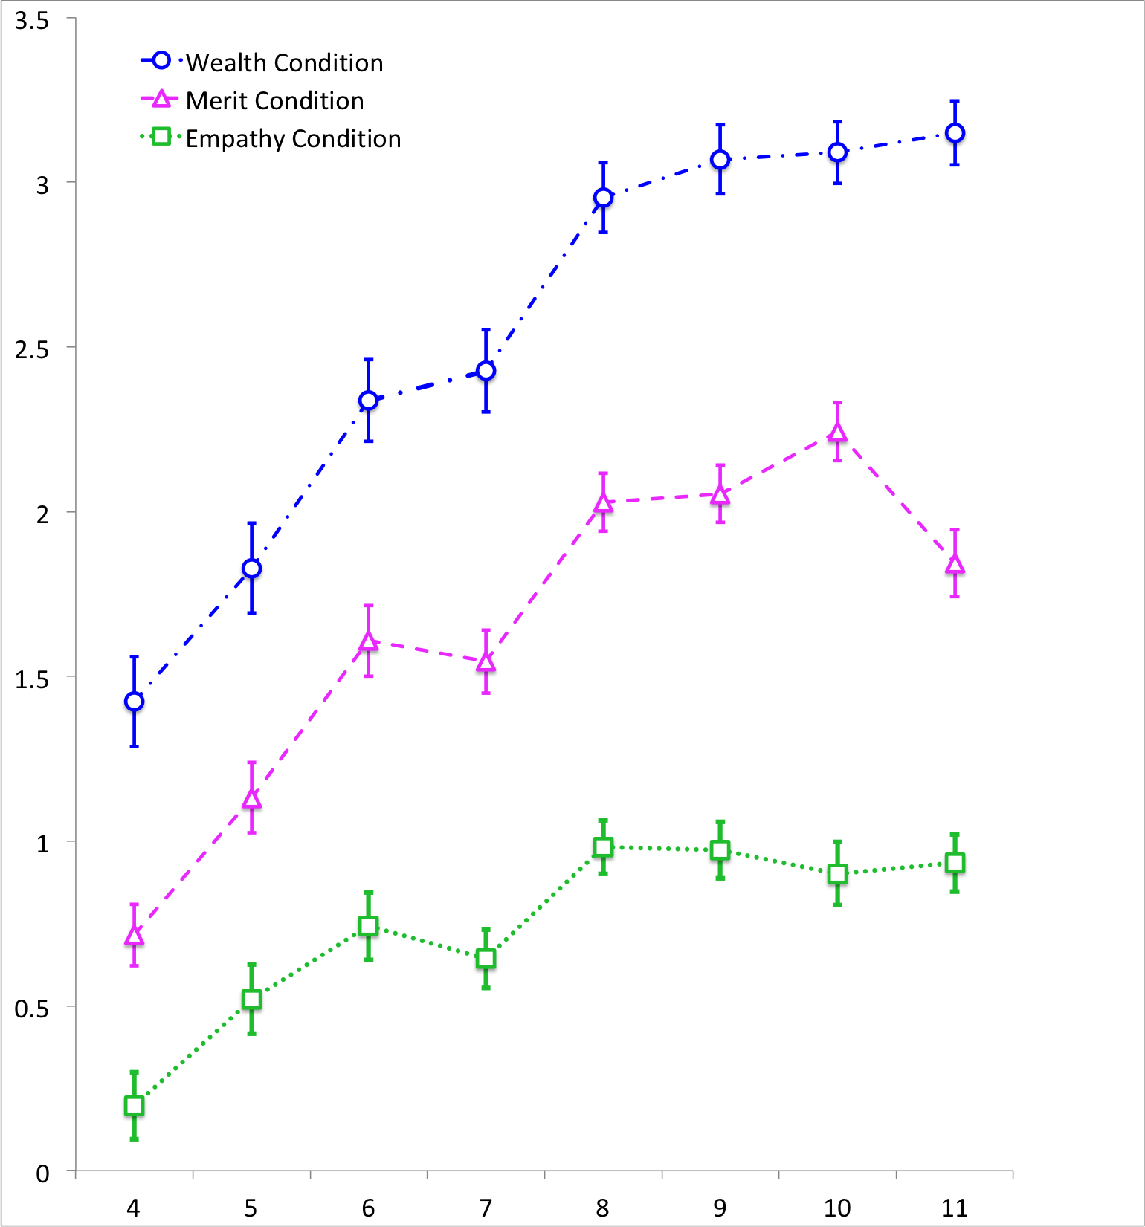

Figure 1. Allocation decisions by children aged 4-11 in the wealth (candies shared with the poor – rich recipient), merit (candies shared with the hardworking – lazy recipient), and empathy (candies shared with the injured – uninjured recipient) conditions.

Allocation Decisions by Age and Culture

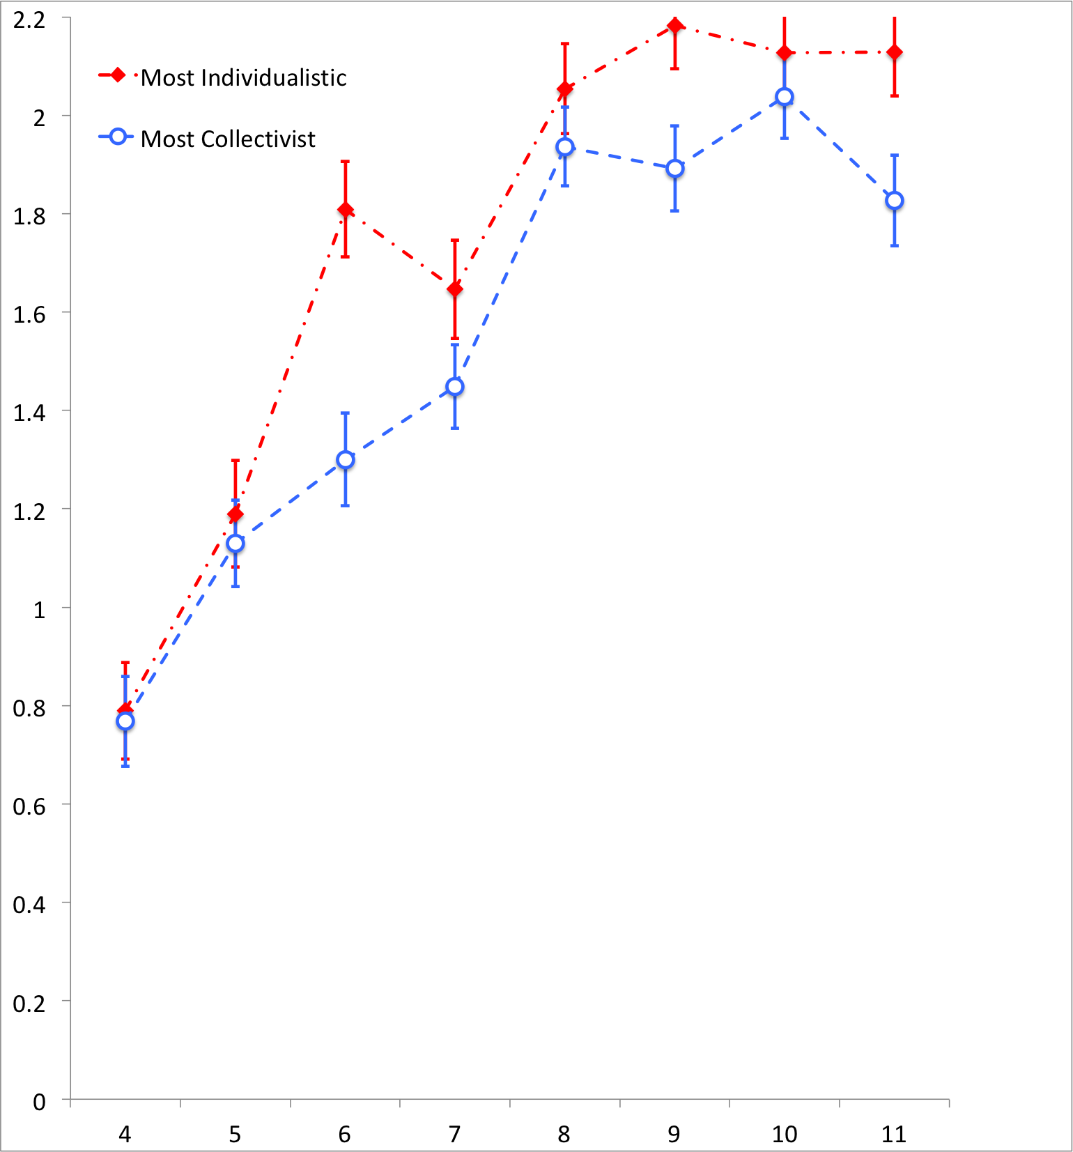

Figure 2. Allocation decisions by children ages 4-11 compared by individualistic and collectivist cultures across all distributive justice game conditions.

Allocation Decisions by Culture and Distributive Justice Game Conditions

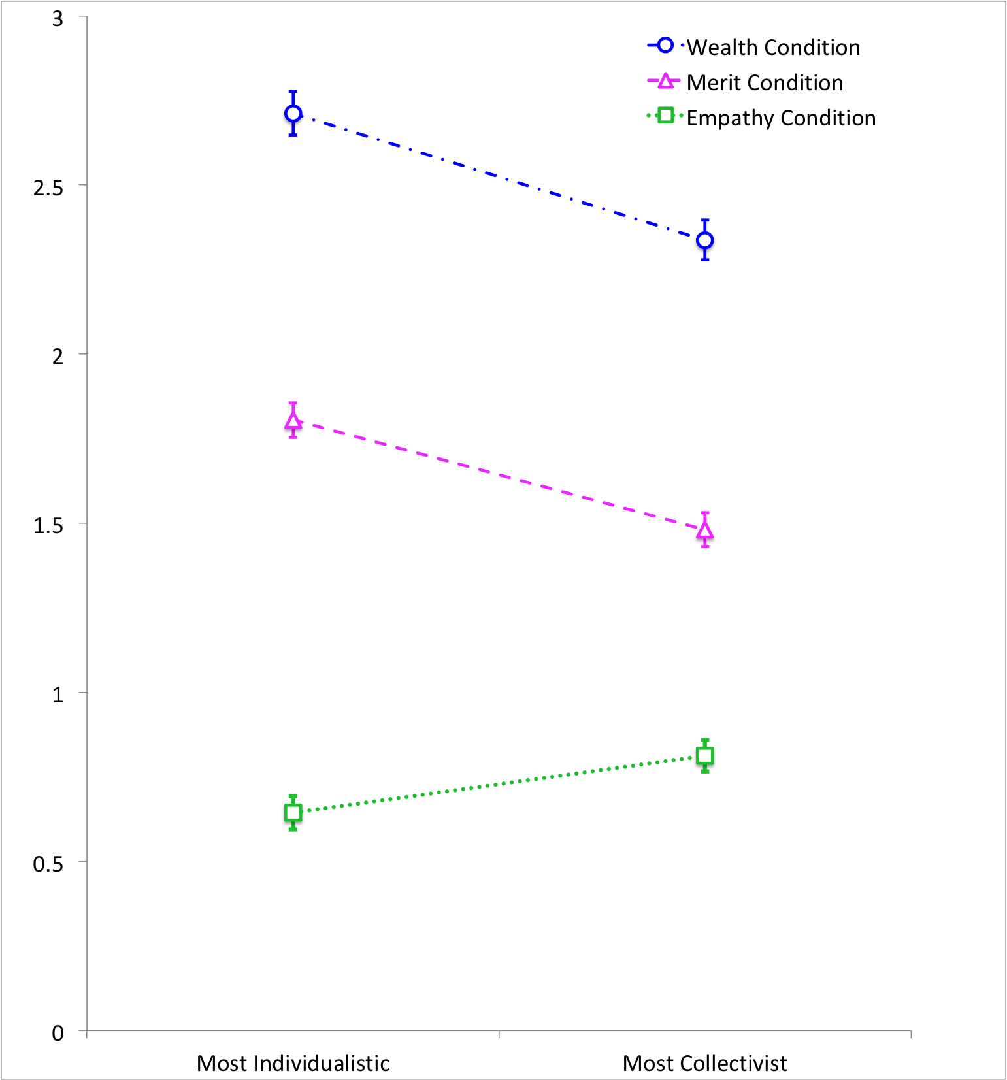

Figure 3. Allocation decisions by children in the wealth, merit, and empathy conditions compared by individualistic and collectivist cultures across all ages.

Allocation Decisions by Age x Culture x Country

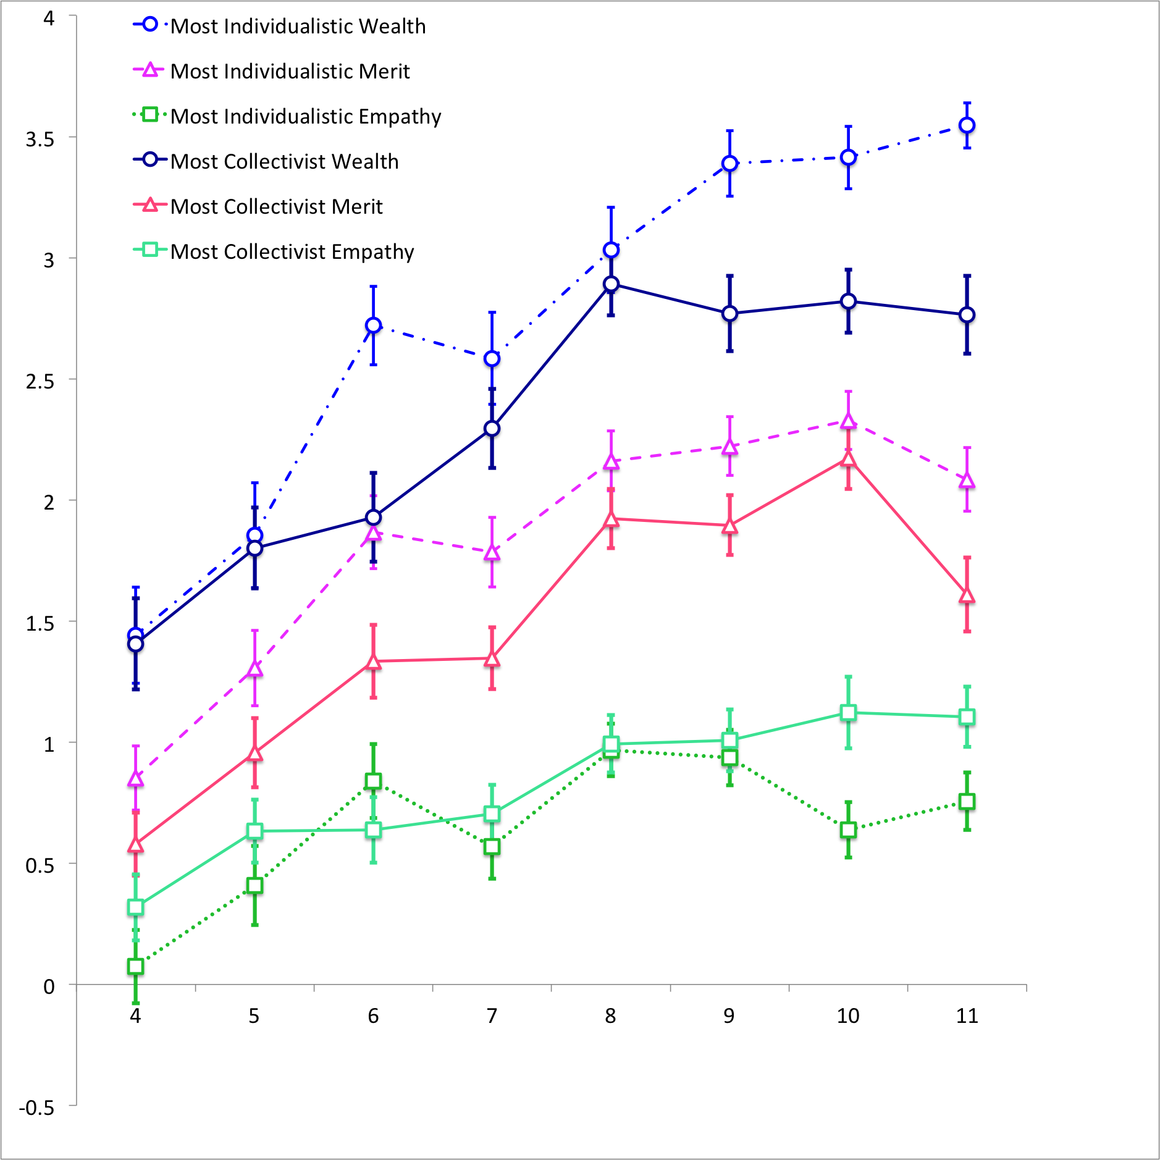

Figure 4. Allocation decisions compared across culture (most individualistic and most collectivist), distributive justice game condition (wealth, merit, and empathy condition), and by age (4-11 years).

